TO: Faculty and Staff in the College of Humanities and Behavioral Sciences
FR: Dr. Matthew J. Smith, Dean
DA: March 19, 2020
RE: Dean’s Report

I began my tenure as Interim Dean in the spring of 2018 and continued in that role until appointed Dean of the College on February 25, 2020, following a national search. During my interview, I spoke about the three pillars upon which my tenure as Dean would be built: a prioritization of students and their educational needs, a desire to recognize people for their contributions, and an expectation of ownership for one’s larger responsibilities within one’s role. I believe those pillars are already evident in the works cited below.

As time has progressed, I have come to enjoy many aspects of this role, but most particularly participating in programming across the breadth of the College, whether that be welcoming prospective Psy.D. students to campus, dining with the Pre-Law speaker, attending the Army ROTC Formal, greeting guests at the Chinese New Year Celebration, or making a presentation in conjunction with the World War II 75th Anniversary Series. When I consider the variety of programming this College makes available to the campus community, it is truly inspiring.

Community Building Initiatives

At the College Meeting in August, I renewed my pledge to introduce efforts to strengthen the sense of shared identity across the College, and to that end pursued the following initiatives:
- Recruited for, promoted, and hosted the “September Series” (featuring our newest tenure-track colleagues) and “Spring Series” (focusing on REAL) lunchtime brown bag lectures to spotlight scholarship and innovation across the College
- Introduced a “Valedictory Series” to honor retiring faculty in Spring 2020 (postponed)
- Hosted “Donuts with the Dean” to meet with faculty, staff, and students
- Continued a College-wide adjunct training workshop in fall
- Supported the CHBS Awards Committee in inaugurating a Distinguished Service Award for 2019
- Invited faculty and staff to the CHBS Luau, a family-friendly social gathering at the end of fall term
- Coordinated the semi-annual meeting of the CHBS Advisory Board in conjunction with the university’s Volunteer Summit, featuring programming from Dr. West Bowers and Mr. Jeremy Jennings

Academic and Managerial Initiatives

Additionally, I undertook the following College-relevant initiatives, as dictated by circumstance and responsibility:
- Conferred with the Office of Advancement—especially our gifts officer, Dr. Carter Turner—to launch strategies towards College fund-raising goals and priorities
- Advocated for resources like faculty lines, especially those vacated by retirements and resignations
- Directed College leadership in responding to a budget reduction exercise requested by the Office of Finance and Administration
- Worked with English faculty in preparing a plan to address staffing needs for the new university-wide foundational writing course, ENGL 111
- Collaborated with our Pre-Law faculty to bring discounted LSAT testing fees to our students and to initiate a 3+3 agreement with Appalachian School of Law
- Met with faculty in Industrial and Organizational Psychology and the School of Communication in the development of proposals for new research centers
- Partnered with our ROTC officers to renew our contractual affiliation with the United States Department of the Army
- Coordinated efforts to present viability reports for FORL and PHRE
- Orchestrated weekly staff meetings for Dean’s Office to improve internal coordination

Searches

I believe that the single most important administrative task we undertake is the hiring of colleagues, as these decisions impact our students for years to come. As such, as dean I consider time collaborating with departments on searches to be time well spent, including the following searches we have conducted within the College:
- Criminal Justice: Chair (pending)
- Criminal Justice: Full-Time Temporary Special Purpose Faculty (pending)
- Political Science: Full-Time Temporary Assistant Professor (Dr. Iulia Hoban)
- Psychology: Full-Time Temporary Special Purpose Faculty (Dr. Sterling Barfield)

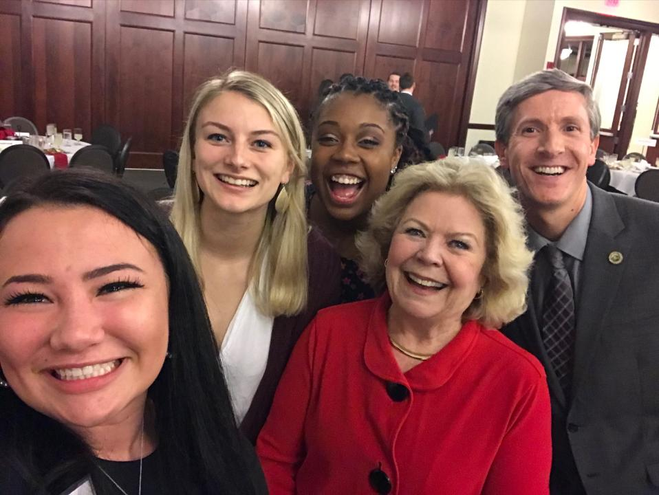
Dr. Smith joins in the fun with Kathleen Harvey Harshberger and students at the Etiquette Dinner.
I have also worked on internal leadership positions involving the Communication, Criminal Justice, and Political Science programs.

In addition, I served on the university-wide search committee for the Provost and Vice President for Academic Affairs (Dr. Lyn Lepre).

Evaluation of Faculty and Staff

A sizeable portion of the dean’s responsibilities involves reviewing and recommending faculty and staff, due in no small part to the fact that we are the largest College in the University. In the past year, I have processed the following:
- 106 Faculty Annual Evaluations
- 45 reappointment reviews for contingent faculty
- 14 tenure and/or promotion recommendations
- 3 emeritus recommendations
- 3 staff annual reviews

Administrative Duties

In addition to those vital personnel matters, I have also maintained responsibility for the following fiduciary, academic, and managerial duties:

Fiduciary Responsibilities:
- Consult with Ms. Stacey Griffin, Executive Secretary, to manage the College’s $11 million budget
- Collaborate with the chairs and director to develop ETF funding requests
- Approve all spending requests across the College through Chrome River

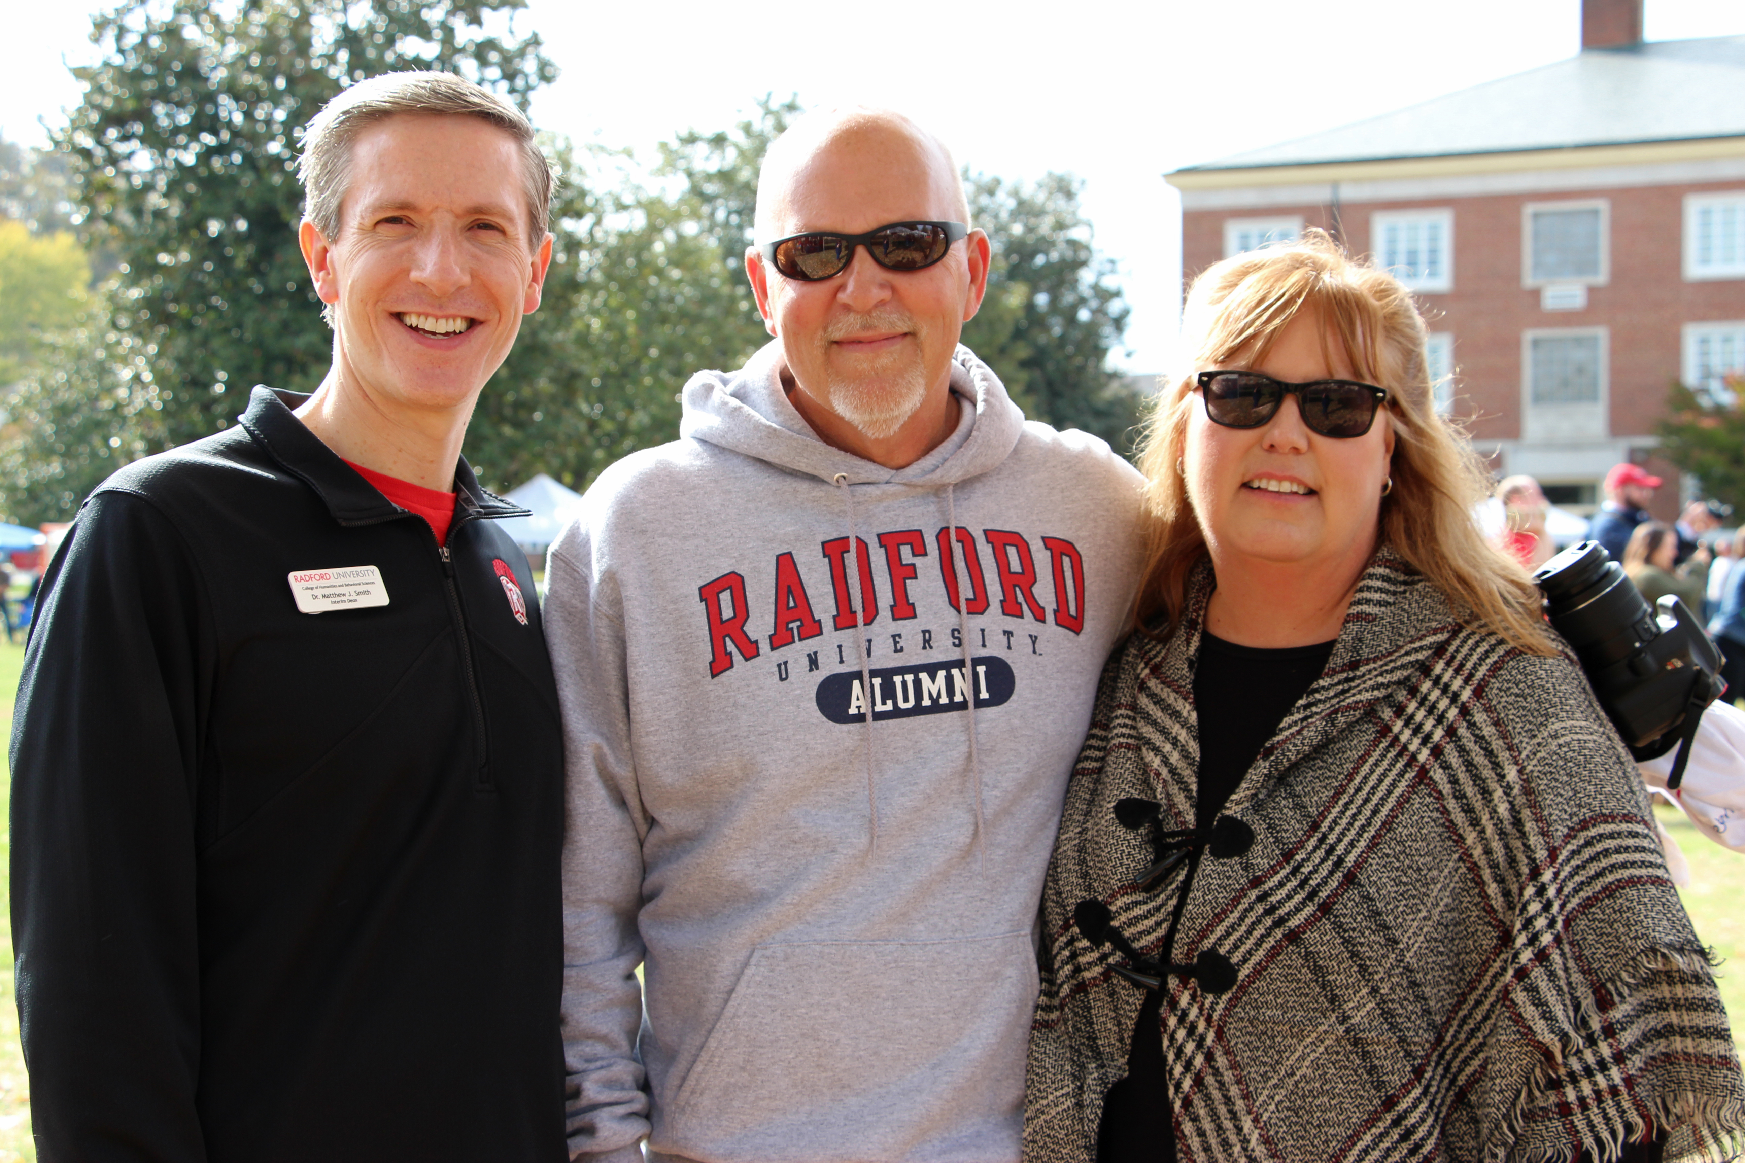
Dr. Smith hosts CHBS Distinguished Alumni Award Winner and NPR News personality Dave Mattingly ‘86 and his wife, Jen, at Homecoming.

Academic Responsibilities:
- Interface with Ms. Gloria Tuckwiller, the Director of the CHBS Advising Center, to review academic petitions and policy changes
- Review all study away/abroad proposals, of which CHBS has the most in the university
- Confer with the Director of the Governor School and the Dean of CVPA in managing Governor School policies, personnel, and budgets
- Work with the College of Education and Human Development on personnel matters related to the Selu Conservancy
- Approve the work of the CHBS Curriculum Committee

Managerial Responsibilities:
- Draft agendas for and preside over bi-weekly meetings of the CHBS Leadership Team
- Meet with individual chairs and directors to address matters in the departments and school (e.g., personnel issues, resource requests, schedules)
- Host the CHBS Advisory Board and its Distinguished Alumni Award ceremony
- Supervise Ms. Kerie Benson, the Assistant to the Dean, in managing the College’s 144,000 square foot facility
- Coordinate with Dr. Kim Gainer, the Associate Dean, to manage projects, ongoing and ad hoc, that benefit from her superior organizational abilities

University Committee Membership
As dean, I have represented the college on four standing university-wide leadership bodies, and served on two other ad hoc committees in the past year:
- President’s Leadership Council
- Academic Affairs Leadership Team (AALT)
- Academic Program Review Committee (APRC)
- Highlander Discovery Institute Steering Committee
- Ad Hoc Committee on the Faculty Recruitment Guide (chair)
- REAL Implementation Steering Committee and its Academic Management Subcommittee

Representing the College

I was honored to represent the College in the following events during the last year:

- Board of Visitors meetings
- Commencement ceremonies
- Dean’s List reception
- Education and Workforce Summit
- Highlander Days
- Homecoming
- Institutional Effectiveness Day
- New Student Convocation
- Quest
- Quiz Bowl
- RUC meetings
- State of the University address
- Taubman Museum collaboration
- Volunteer Summit

Teaching
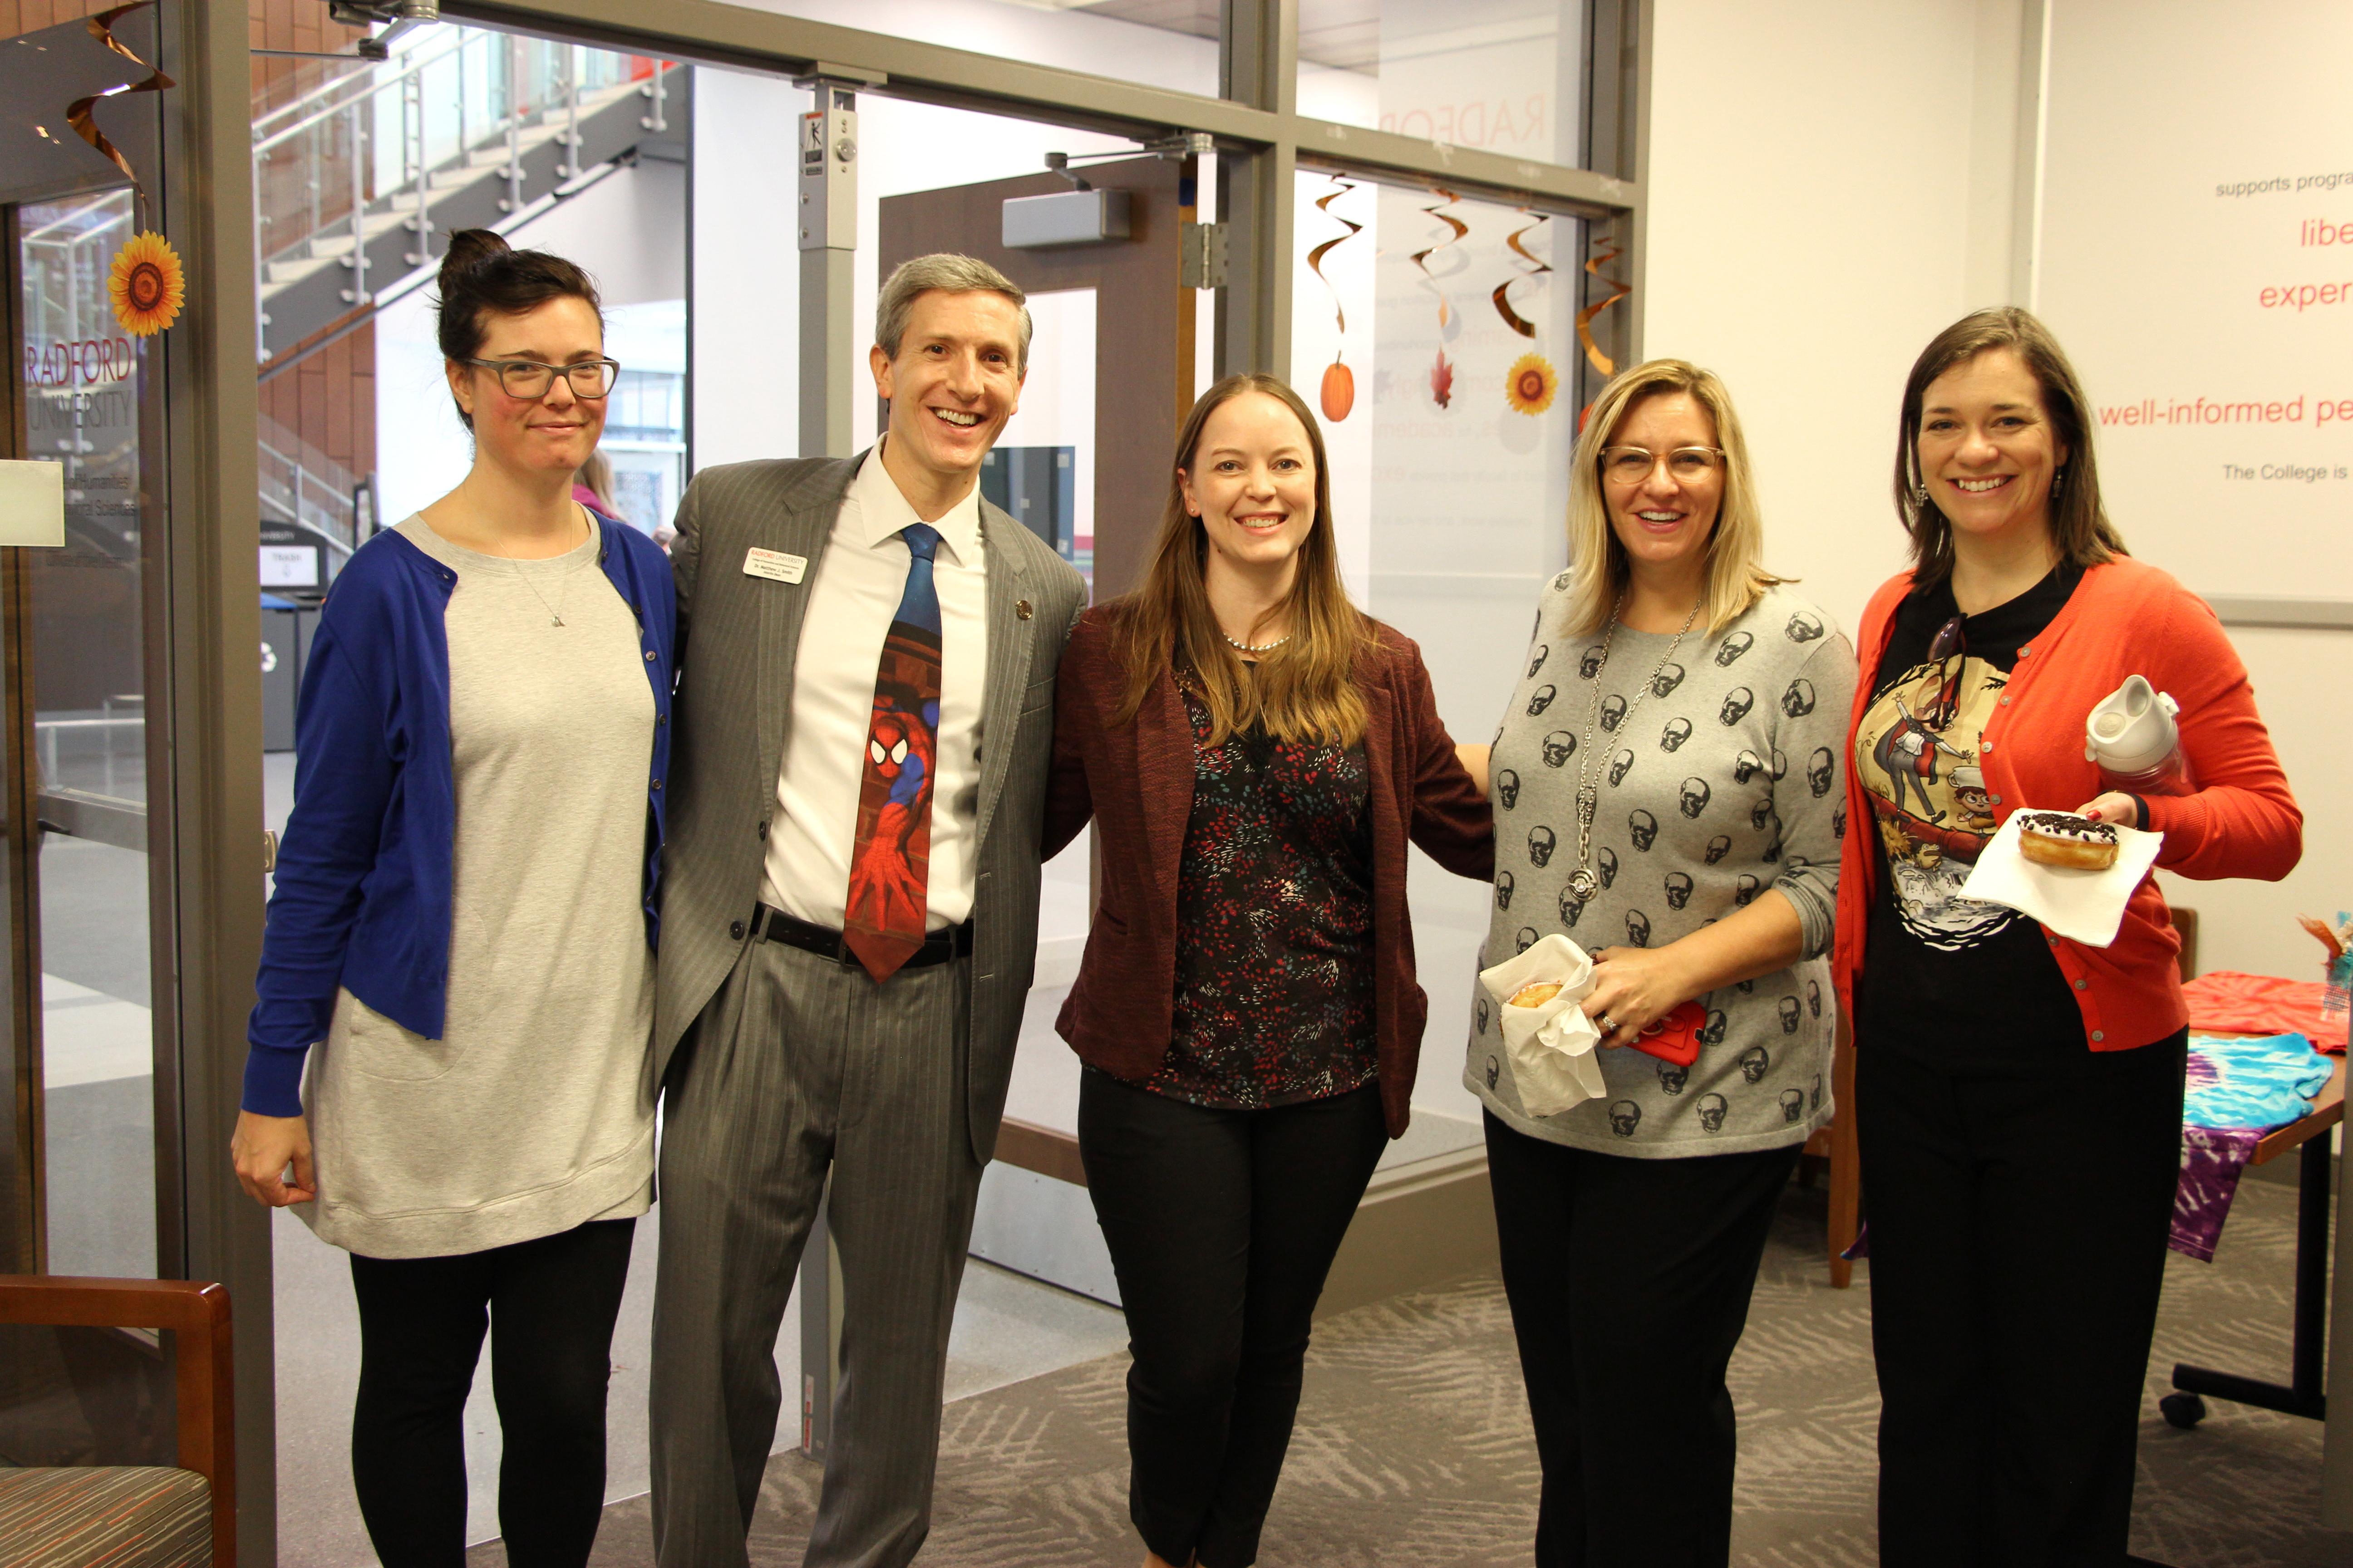
In the past year, I have conducted the following instructional activities:
- Taught COMS 460 Topics: Event Planning (3 credits) to 18 students in Spring 2019 in collaboration with Dr. John Brummette
- Directed the M.S. thesis for Ms. Rebecca Hogge, who graduated in May 2019
- Served as outside reader on the doctoral dissertation of Claire Pitkethly at the University of Melbourne, in Spring 2019
Dr. Smith hosts faculty along with staff and students at “Donuts with the Dean” on Halloween.
- Led COMS 460 Topics: The Experience at Comic-Con (1 credit) for 11 students traveling to San Diego on July 16-22
- Taught ENGL 414 / COMS 460 Topics: Graphic Storytelling to 10 students in Fall 2019

At present, I am working on one additional instructional activity:
- Teaching COMS 439 /539 Communication and Leadership (3 credits) to 20 undergraduates and 4 graduate students in Spring 2020

Scholarship

A number of projects came to fruition over the course of this academic year, including:
- Conducted co-curating duties on “Marvel: Universe of Super Heroes,” including delivering a public lecture at the Franklin Institute and attending the opening of the Philadelphia, PA, show; thus far, the exhibit has hosted more than 750,000 people since debuting in 2018
- Published my eleventh book, More Critical Approaches to Comics: Theories and Methods, for Routledge in summer 2019
- Delivered “Hail to the King!” Jack Kirby and the Comic Book Roots of the Black Panther” and chaired an additional panel at the National Communication Association conference in Baltimore, MD, in November 2019
- Contributed expert commentary to an article featured in Forbes on graphic storytelling appearing in the April 11, 2019 online edition

In addition to those, I am still working on the following:
- Co-editing the Routledge Advances in Comics Series, publishing three volumes in 2019
- Preparing “Crisis Management: Arrowverse Cross-Overs as Media Consumption Strategy” for inclusion in the program of the National Communication Association Conference in Indianapolis, IN, in November 2020

Professional Service
I am serving as conference co-planner and First Vice President of the Comics Studies Society, whose “Comics & Technology” conference will convene at Henderson State University on August 5-9, 2020.

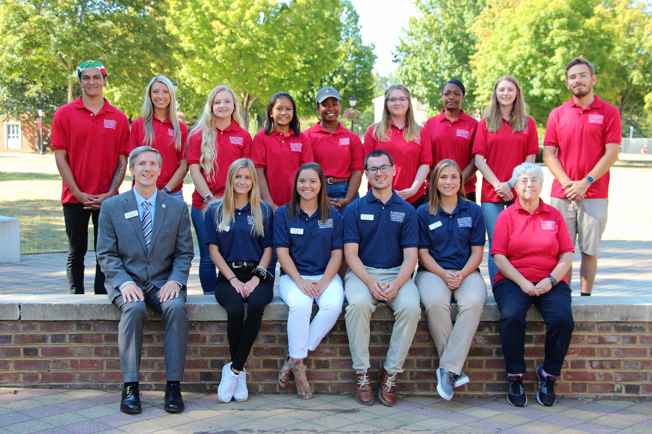
Dr. Smith poses with the student volunteers in the CHBS Ambassadors program along with Associate Dean Kim Gainer.

I have sincerely appreciated the opportunity to serve the College this year, and I am grateful to everyone who has demonstrated their support throughout this transitional period.

Sincerely,

Matthew J. Smith, Ph.D.

