2021 Nutrient Management Plan
Prepared For:
Radford University
Christopher Shelton – Landscape Superintendent 801 East Main Street
Radford, Virginia 24142
540-831-7767
Prepared By:
Five Oaks Agronomy Consulting Robert Habel, CNMP
192 Briarherst Drive
Amherst, Virginia 24521
Cell: 434-665-2813
habelrf@gmail.com Certification Code: 654

Acreage - 9 Fields, 6 Common Areas, 11 Soil Samples (Breakdown on Page 4)
Total: | 94.6

County: | City of Radford
Watershed: | NE57 – Upper New River, Back Creek, Connelly’s Run

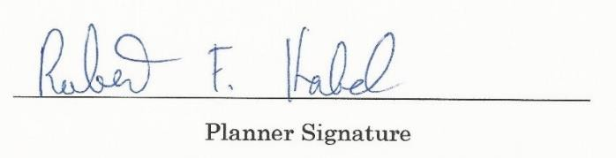
Plan Written: June 1, 2021

Plan Expires: June 1, 2024
add signature

Contents

- Narative 5
  - Statement of Compliance 5
  - Plan Overview 5
  - Location 6
  - Nutrient Management Principals 8
  - Best Management Practices for Water Quality Protection 11
  - Application Equipment Calibration 11
  - Environmentally Sensitive Areas/Concerns 12
  - Season of Fertilization 13
- Management Areas 14
  - Main Campus 14
  - Dedmon Athletic Complex 16
  - Cupp Stadium 18
  - Field Hockey 20
  - Softball 22
  - Practice Fields 24
  - IM Fields 26
  - IM/Rec Sports Common Area 28
  - Residential Area 30
  - Baseball 32
- Soil Test Summaries 33
  - Main Campus 35
  - Dedmon Athletic Complex 36
  - Cupp Stadium 37
  - Field Hockey 38
  - Softball 39
  - Practice Fields 40
  - IM Fields 41
  - IM/Rec Sports Common Area 42
  - Residential 43
- Nutrient Application Worksheets 44
  - Main Campus 45
  - Dedmon Athletic Complex 46
  - Cupp Stadium 47
  - Field Hockey 49
  - Softball 51
  - Practice Fields 53
  - IM Fields 55
  - IM/Rec Sports Common Area 57
  - Residential 58
- Fertilizer Application Records 59
- Reference Material 68
- Fertilizer Labels 84
- Soil Test Results 86

Sources:
Maps – Maps are produced using Google Earth or provided by client. Photos/Logos – Obtained from client, clients website, or taken by planner. Site information – Obtained from client or clients website.
Technical Information –
Agronomy Handbook – A&L Labs – 2001
Best Golf Course Management Practices – McCarty – 2001
Environmental Best Management Practices for Golf Courses – Virginia GCSAA – January 2012 Golf Course Management and Construction, Environmental Issues – Balogh, Walker, USGA – 1992 Soil Fertility and Fertilizers 6th Ed. – Havlin, Beaton, Tisdale, Nelson – 1999
Spectrum Analytic Agronomic Library – www.spectrumanalytic.com
Sports Turf Management in the Transition Zone – Goatley, Askew, Ervin, Mcall, VSTMA, Etc. – 2008 Turf Management for Golf Courses 2nd Ed. – Beard, USGA – 2002
Turfgrass Soil Fertility and Chemical Problems – Carrow, Waddington, Rieke – 2001
Urban Nutrient Management Handbook – VA DCR, Virginia Tech, Virginia State Uni. – May 2011 Virginia Nutrient Management Standards and Criteria – Commonwealth of Virginia – July 2014
Disclaimer: Statements and recommendations made within this document based on published research data and experience. Recommendations are based on the soil tests included in this document and not intended for use on any other facility. Products suggested are used in methods suggest by label guidelines when available, be sure to read label before using products as labels can change. Maximum rates are provided by Virginia Department of Conservation and Recreation Standards and Criteria and are not to be exceeded even when product label suggests otherwise. No guarantee or warranty is made, expressed or implied, concerning crop performance as a result of using the contents of this document.

Narative

Statement of Compliance
As a State-Owned Land, Radford University is required to have and follow a Nutrient Management plan. Thus, they agree to comply with all requirements set forth in the Nutrient Management Training and Certification Regulations, 4VAC50-85-10 et seq., and to follow recommendations for turf fertilization and management as described in the Virginia Nutrient Management Standards and Criteria, Revised July 2014. This includes implementing this Department of Conservation and Recreation approved Nutrient Management Plan and maintaining fertilization records. All nutrient applications to Radford University property, performed by Radford University staff or other contractors, shall comply with the provisions of this Nutrient Management Plan as of June 1, 2021. This plan is affective for three years (until June 1, 2024) or until major renovations or major changes to maintenance practices occur. The planner should be alerted if this occurs or if new soil tests are taken within the three-year period, a minor revision may be needed if tests show major differences. The process of updating this plan for a new three-year cycle should begin no later than 6 months prior to plan expiration.

Plan Overview
This plan covers 93.9 acres including 5 warm season athletic fields, 4 cool season athletic fields and 6 cool season common areas scattered across the Radford University campus. Each location will be discussed separately.
Radford University is a comprehensive, midsize public university that is student-focused, providing its more than 9,700 students a diversity of outstanding academic programs. Well known for its strong faculty/student bonds, innovative use of technology in the learning environment and vibrant student life on a beautiful campus, Radford University offers many opportunities to get involved and succeed in and out of the classroom.
Radford University welcomes students from the Commonwealth of Virginia, across the country and around the world. Here, you will find inspiration in the surroundings – the manicured green lawns on campus, the steady roll of the New River, the wonders along the Blue Ridge Parkway, the stately university buildings and a quaint downtown. Radford’s more than 150 undergraduate and graduate programs offer every student the opportunity to discover new talents, develop leadership skills, and experience personal growth.
Radford University is committed to being a model for sustainable campus practices and policies and recognized for their stewardship of economic, social, and environmental resources and for their academic commitment to sustainability. For more info on Radford’s sustainABILITY program, visit (http://www.radford.edu/content/sustainability/home.html).

Location
Radford is just 36 miles southwest of the city of Roanoke, and within easy driving distance of many mid-East Coast metropolitan areas. Richmond is only a three-and-a-half-hour drive, while Washington, D.C., and the Tidewater area are only about four and a half hours away.
From Interstate 81, take Exit 109 onto Route 177/Tyler Avenue into Radford. At the third traffic light, turn right onto Jefferson Street. At the next traffic light, turn left onto East Main Street.
The main university entrance will be on your left, at the intersection with University Drive. Visitors to the Dedmon Center should turn right on University Drive to reach the facility.
GPS: 37.138088, -80.550010
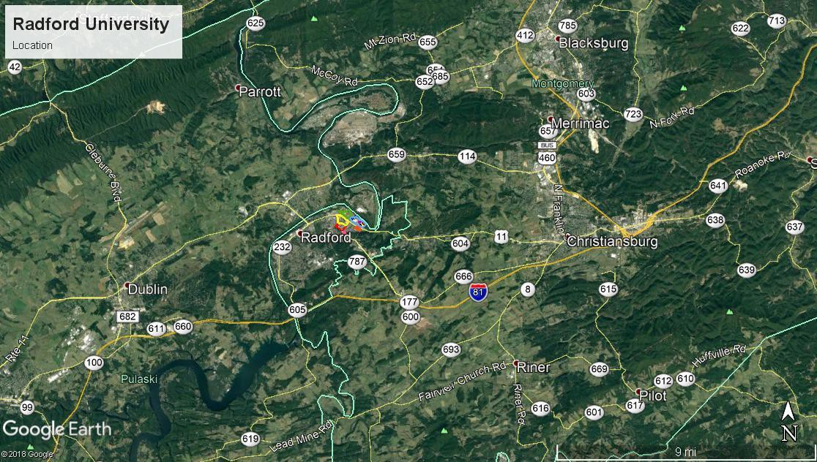

Location/Acreage/Watershed Code Breakdown
Location | Acres | Grass | Irrigation | Color | Watershed
Campus - North | 23 | Cool |  |  | NE57 94.6  Acres
Campus – South | 14 | Cool
Dedmon – West | 17 | Cool
Dedmon – East | 20 | Cool
Fields located in Dedmon East
Cupp Stadium | 2.3 | Warm | Yes
Field Hockey | 2 | Warm | Yes
Softball | 0.7 | Warm | Yes
Practice Fields – Upper and Lower | 4.6 | Warm | Yes
IM Middle, Softball, Rugby | 6.5 | Cool | Yes
IM/Rec Sports Complex Common Area | 3.3 | Cool
Residential Area | 1.2 | Cool
Total | 94.6

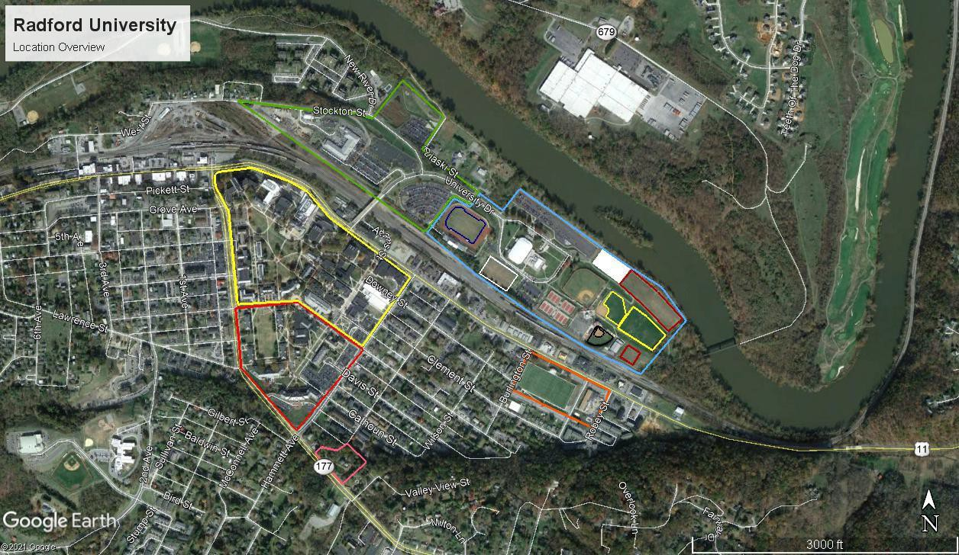

Nutrient Management Principals
Nutrient Management Plans focus on two primary objectives healthy plants and clean water.
There are four different types of elements essential for plant health. Non-mineral, Primary and Secondary elements are all considered Macronutrients. The fourth is Micronutrients. Non- mineral elements consist of carbon, hydrogen, and oxygen; these elements are obtained from air and water. The Primary nutrients are nitrogen, phosphorus, and potassium. Secondary elements are calcium, magnesium, and sulfur. Micronutrients are iron, manganese, boron, zinc copper, molybdenum, chlorine, cobalt, and nickel. These elements are obtained from the soil and must be supplemented with fertilizer, lime or other soil amendments when a soil test shows a deficiency. In high maintenance situations, some elements are spray applied and absorbed through the leaf tissue.
Nitrogen and phosphorus are the focus of a nutrient management plan, as these nutrients cause ecological problems. Lime is also important because having improper pH can make applied fertilizers unavailable to the plant and more likely to leach or runoff. While nitrogen and phosphorus are the focus, other nutrients are also discussed in the plan, these nutrients are beneficial to plant health, but do not cause water quality problems.
Soil tests are required to determine the current level of soil nutrients available to the plant so fertilizer can be applied at rates that ensure excess nutrients do not enter our waters. Basic soil tests provide data on phosphorus, potassium, magnesium, calcium and pH. Nitrogen cannot be tested for using a basic soil test as it is very volatile. Magnesium and calcium are included in basic soil tests so that proper liming materials can be chosen.
Soil test results are compared to a reference guide provided by DCR. These Standards and Criteria are based upon years of scientific research and the rates suggested are optimal for plant health within the intended usage. Low input areas, like home lawns, require some fertilizer to maintain plant vigor thus maintaining turf cover and preventing erosion. High use areas, like sports fields, require frequent fertilizer input to help maintain plant health and to aid in recovery from stress. Clean water is maintained by applying fertilizer in a responsible manner that ensures minimum movement away from the intended site.
The following information discusses the role of the nutrients in the plant. Highlighted information is specific to this plan.

Nitrogen (N) – This element is responsible for green color, shoot growth and density, root growth, carbohydrate reserves, recuperative potential, heat, cold, drought hardiness, wear tolerance, and disease susceptibility. Nitrogen has a very complex cycle and only certain forms are available to the plant. It leaches through the soil rapidly and does not accumulate thus you cannot soil test for N. Due to these factors, nitrogen management is a large part of nutrient management. Nitrogen management includes but is not limited to using slow release materials, timing the applications in accordance with plant growth, and making multiple applications so that the element is available when it is needed by the plant.
There are multiple nitrogen rates used in this plan. Slow release products were used exclusively. Labels are included at end of plan. If making changes, please continue to use slow release fertilizers, or contact your planner for help determining the proper rates.

Phosphorus (P) – Phosphorus controls the establishment rate of newly seeded turf, plant maturation, root growth, and seed production. Like nitrogen, P also has a complex cycle. The major difference is that P readily attaches soil, it can be quantified by a soil test and only

leaches when it completely saturates the soil. Phosphorus moves away from the application site when it is improperly applied to compacted soil or other impervious surfaces, when applied in excess, and since it attaches to the soil, with sediment rich runoff. Phosphorus management is also important to nutrient management. It should only be applied when called for by a soil test, to soils that are not compacted to prevent runoff and only applied to actively growing turf with sufficient turf cover/rooting to hold the soil in place.
Maximum P rates are outlined in application worksheets. Do not exceed this number.
Potassium (K) - Potassium is responsible for root growth, heat, cold, and drought hardiness, wear tolerance, and disease susceptibility. While the Standards and Criteria do regulate the application of K, but in some cases, K input may exceed recommended levels, as it does not have the same detrimental effects on the health of Virginia’s waters as N and P. Potassium is considered the plant nutrient most responsible for turf quality. It helps plants respond to stresses like drought, extreme heat/cold, and insect/disease pressure. The plants increased ability to respond to stress in a positive manner can help reduce the need for increased N and P fertility and reseeding caused by stress. In addition to the benefits of K, it is difficult to limit the amount of K used as most modern slow release fertilizers contain both N and K while limiting or completely removing P. Nitrogen only products are not readily available in slow release form and custom blended fertilizers are expensive.
Potassium levels have been exceeded in most of areas of this plan. As discussed above, K helps the plant deal with stress. Sports fields and common areas are generally stressed be it from excessive use, compaction, improper pH, or lack of proper care due to budget and personnel restraints.

Lime - Liming is a critical management practice for maintaining soil pH at optimal levels for plant growth. Liming supplies the essential elements Calcium and/or Magnesium, reduces the solubility and potential toxicity of Aluminum and Manganese, and increases the availability of essential nutrients. Many soil elements change form because of chemical reactions in the soil due to pHs that are either too acidic or too basic. Plants may not be able to use elements in some of these forms making some elements essential to plant health unavailable. Most plants grow well in the pH range 5.8 to 6.5.
Buffer pH is used to provide an indication of the soil’s total (active + reserve) acidity and ability to resist a change in pH. This buffer measurement is the major factor in determining the amount of lime to apply. The Buffer pH starts at 7 (no lime needed) and goes lower as the soil’s total acidity increases and more lime is needed to raise the soil pH. As an example, a clay soil with a pH of 6.1 could have a buffer pH of 6.8 and need 1 ton/A of lime in order to maintain/increase that pH around 6.2. A sandy soil could have a much lower pH but have the same buffer pH thus, needing the same amount of lime to change the pH to 6.2. This is because sandy soils have a lower cation exchange capacity thus, less storage for reserve acid.
Attempting to change the pH in the deep rooting zone of an established turf is difficult at best. One method of getting lime somewhat deeper in established turf areas is to apply lime in conjunction with aeration. Applying lime in the fall and winter months is recommended because the freeze/thaw cycle aids in mixing lime throughout the root zone.
Lime provides the essential nutrients Calcium and Magnesium. Calcium is the main component of plant cell walls while magnesium is the atom upon which chlorophyll is built. It is important that these elements be present in the soil not only to help regulate the soils acidity but to insure plant health. When a soils pH is acidic, these elements can be added with lime. Calcitic

lime should be used when calcium is deficient, and magnesium is high. Dolomitic lime, which is more common, is used when the both are deficient or balanced. If pH does not need to be adjusted, calcium levels can be raised with gypsum and magnesium is raised with Epsom salts. The Standards and Criteria provide guidance on adjusting soil pH levels but do not include any recommendations for Ca or Mg, as they do not affect water quality.
Not all liming materials are the same, if the liming material chosen does not equate to 100% Calcium Carbonate Equivalent (CCE% should be listed on bag) see chart on page 83 to adjust the required amount of lime.
Lime specifics are discussed in each section.

Sulfur (S) - Sulfur is responsible for the plants green color, shoot growth and density, root growth, carbohydrate reserves, and disease susceptibility. Elemental sulfur applications should be avoided unless you are attempting to acidify (lower pH) the soil and should be applied at no more than 5#/M and watered in due to the turf burn potential. Unless called for by a soil test, the occasional use of sulfur containing fertilizers and micro nutrient packages should be the only S input needed to supplement the soil S content. This element is not included in the Standards and Criteria.
Iron (Fe) – Iron contributes to the plants green color, shoot growth and density, root growth, carbohydrate reserves, heat, cold and drought hardiness and wear tolerance. Iron is often included in fertilizer and micronutrient blends because it produces a faster greening of turf than nitrogen. According to the Standards and Criteria, Fe applications can be occasionally substituted for N applications because it produces greening. This is a good strategy, but Fe apps cannot replace N. While Fe is used inside the plant, the greening created by Fe is superficial and caused by the iron rusting on the plants surface. Fe should be used as an N replacement only when the plant is healthy, and greening is desired without increased growth.
Micros – Other micronutrients are not mentioned by the Standards and Criteria. These elements are very important to plant growth, but regular input is not needed unless you are managing a sand-based soil with low nutrient holding capacity. Most soils contain all the necessary micros and they will be available for the plant if the proper pH is maintained.

Best Management Practices for Water Quality Protection
The following list comes from the Urban Nutrient Management Handbook page 8-12 and details steps that can reduce the impact of nutrient management practices on water quality. A PDF of the complete handbook can be found online through ext.vt.edu, on the CD provided with the plan or a printed copy can be obtained from DCR.
- Base fertilization practices on a soil test.
- Supplement the soil test with a plant tissue test when necessary.
- Aerate compacted soil to reduce runoff and aid phosphorus and lime in entering the soil.
- Minimize fertilizer rates on slopes and sandy soils. If using quickly available sources of nitrogen on deep, sandy soils or near shallow water tables, use no more than 0.25 to 0.50 pound of nitrogen per 1,000 square feet per application.
- Establish and maintain a buffer zone of reduced- to zero-input vegetation around bodies of water. In some cases, native vegetation might be appropriate, but whatever plant material is selected, it must persist indefinitely to serve as a functional buffer zone.
- Consider using iron as a supplement to nitrogen for greening response.
- Use at least 50 percent slowly available sources of nitrogen on soils subject to leaching.
- Time applications carefully. Do not apply fertilizer before a heavy rainfall.
- Irrigate lightly (0.10 to 0.25 inch) after each application of quick-release fertilizer so it is washed off the foliage and moved into the soil. (Wait to irrigate if foliar activity is desired)
- Avoid over irrigation.
- Return grass clippings to the turf to improve nutrient cycling and reduce the amount of fertilizer needed to produce healthy plants. Use a mulching mower whenever possible and consider that a mulching mower can even be used to manage fall leaves (Goatley 2006).
- When collected, compost grass clippings rather than disposing of them in landfills.
- Use a drop (gravity) spreader near bodies of water or impenetrable areas to lessen the chance of spreading material on these surfaces.
- Perhaps the most important best management practice toward improving water quality is to simply sweep or blow fertilizers and clippings off hardscape surfaces and back into the turf.

Application Equipment Calibration
An agronomically and environmentally sound fertilizer program can be negated by improperly calibrated equipment. It is important to calibrate your equipment prior to every application. Even moving from one location to another can knock your application equipment out of adjustment so once you have your equipment calibrated for a particular product write down the setting. Use that setting to check the calibration for every site and adjust if necessary. The next time you use that product, use your records as a starting point and not a final calibration as equipment can wear over time thus changing the calibration point. For more information on how to calibrate your equipment see the Urban Nutrient Management Handbook Chapter 10 (ext.vt.edu) or visit your equipment manufactures website. Please remember that the number on the bag is not sufficient, every spreader and every application is different, and that the bag number only serves as a calibration starting point.

Environmentally Sensitive Areas/Concerns
    - The New River flows to the north of the fields. There is a sufficient buffer and a berm to protect the river, but fertilizer apps should be avoided when heavy rain is expected.
    - According to Web Soil Survey, there is no indication of flood risk in this area.
    - There are roads, sidewalks and storm water drains throughout the area. Be cautious when making fertilizer applications near these areas and always clean up any fertilizers accidently spread on pavement and sidewalks. If possible, cover drains to prevent direct application of fertilizer to water.
    - Applications of inorganic fertilizers will not occur on frozen or snow-covered ground.
    - Any fertilizer that makes its way onto impervious surfaces (sidewalks, roads, etc.) should be swept or blown back into pervious turfgrass-covered areas.
    - Cover any catchment basins before applying fertilizer so product is not applied directly into these runoff catchment systems.
    - Do not use fertilizers as ice melt.
    - With the numerous small areas, a narrow drop spreader would be a wonderful application tool to have; at minimum, a broadcast spreader with a right-side shield and cutoff is suggested.
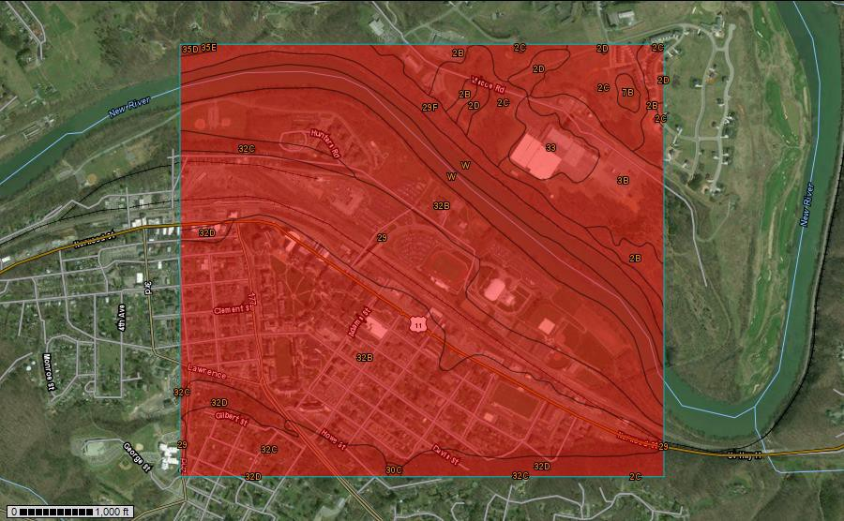
Flooding Frequency Class Designations – Areas indicated as flood prone by Web Soil Survey. Flooding is the temporary inundation of an area caused by overflowing streams, by runoff from adjacent slopes, or by tides. Water standing for short periods after rainfall or snowmelt is not considered flooding, and water standing in swamps and marshes is considered ponding rather than flooding.
Frequency is expressed as none, very rare, rare, occasional, frequent, and very frequent.
"None" means that flooding is not probable. The chance of flooding is nearly 0 percent in any year. Flooding occurs less than once in 500 years.
"Very rare" means that flooding is very unlikely but possible under extremely unusual weather
conditions. The chance of flooding is less than 1 percent in any year.
"Rare" means that flooding is unlikely but possible under unusual weather conditions. The chance of flooding is 1 to 5 percent in any year.
"Occasional" means that flooding occurs infrequently under normal weather conditions. The
chance of flooding is 5 to 50 percent in any year.
"Frequent" means that flooding is likely to occur often under normal weather conditions. The chance of flooding is more than 50 percent in any year but is less than 50 percent in all months in any year.
"Very frequent" means that flooding is likely to occur very often under normal weather
conditions. The chance of flooding is more than 50 percent in all months of any year.

Season of Fertilization
Per the Virginia Nutrient Management Standards and Criteria, Revised July 2014, fertilizers must be applied in between the following dates.
    - These are guidelines and averages, in warmer years, fertilizer could be applied earlier and in cooler years, fertilizer should be applied later.
    - Fertilizers should not be applied to frozen ground or to grass that is not actively growing. For warm season grasses please wait for green up to occur.
    - For warm season grasses that are overseeded, follow the cool season application window. If overseeding is skipped, please revert to warm season window.
    - The acceptable nitrogen fertilizer application season for non-overseeded warm season turfgrass begins no earlier than the last spring average killing frost date and ends no later than one month prior to the first fall average killing frost date.
    - The nutrient management recommended application season for nitrogen fertilizers to cool season turfgrasses begins six weeks prior to the last spring average killing frost date and ends six weeks past the first fall average killing frost date.

Data for frost date comes from the Northeast RCC CLIMOD 2 Frost/Freeze Summary for Christiansburg, VA climate station.
http://climod2.nrcc.cornell.edu/

 | Average Frost Dates | Cool Season Applications | Warm Season Applications
Spring | April 16 | March 5 | April 16
Fall | October 23 | December 4 | September 23

Maps - Satellite and topo maps created using Google Earth are to scale as shown in bottom left of each map. For all maps, unless otherwise indicated, North is oriented towards top of page.
Nutrient Applications - Each location addressed by this plan has its own section. Some sections cover multiple management areas. A nutrient application worksheet for each management area of that location is included as the last page(s) of that section of the plan. Application records are all located in one section together or on the disk provided. A blank worksheet is also included on the disk to help with calculations if any changes in fertilizer analysis occur. Do not hesitate to call if there are questions.

Management Areas
For sections 2, 3 and 4, sub headings will refer to the same location. Details of each management area will be discussed in section 2, soil test information will be discussed in section 3 and application worksheets will be discussed in section 4.

Main Campus
Description
The university atmosphere is residential. Most students live in university residence halls or in private apartments and houses within walking distance of the campus. The university grounds and facilities are conveniently arranged, beautifully maintained, and effectively designed to meet the academic, personal, and extracurricular needs and interests of the students.
The area provides abundant recreation, including kayaking, fishing and tubing on the New River; hiking or bicycling on one of the region's dozens of trails; or simply taking in nature nearly anywhere in the area.
The area to the west of Tyler Ave is no longer maintained by the school.
Location
Radford’s main campus area is in the triangle formed by Rt. 11 (Lee Hwy./Main St.), Jefferson Street and Tyler Avenue.
GPS Coordinates: 37.138088, -80.550010
Areas Managed
Two samples were taken from this area, one from the North and South areas of campus. Fairfax Street separates the two areas. They are managed the same and both are cool season grass. The need for two samples was dictated by the size of the area. Soil tests show marginal differences and will be combined into one recommendation. Buildings, roads, and sidewalks were roughly measured using goggle earth and were subtracted from total acreage of 53.6 acres north and 31.6 acres south.
North Campus – Outlined in yellow. About 23 acres cool season turf. The predominate turf species is tall fescue.
South Campus – Outlined in red. About 14 acres cool season turf. The predominate turf species is tall fescue.

- | P a g e

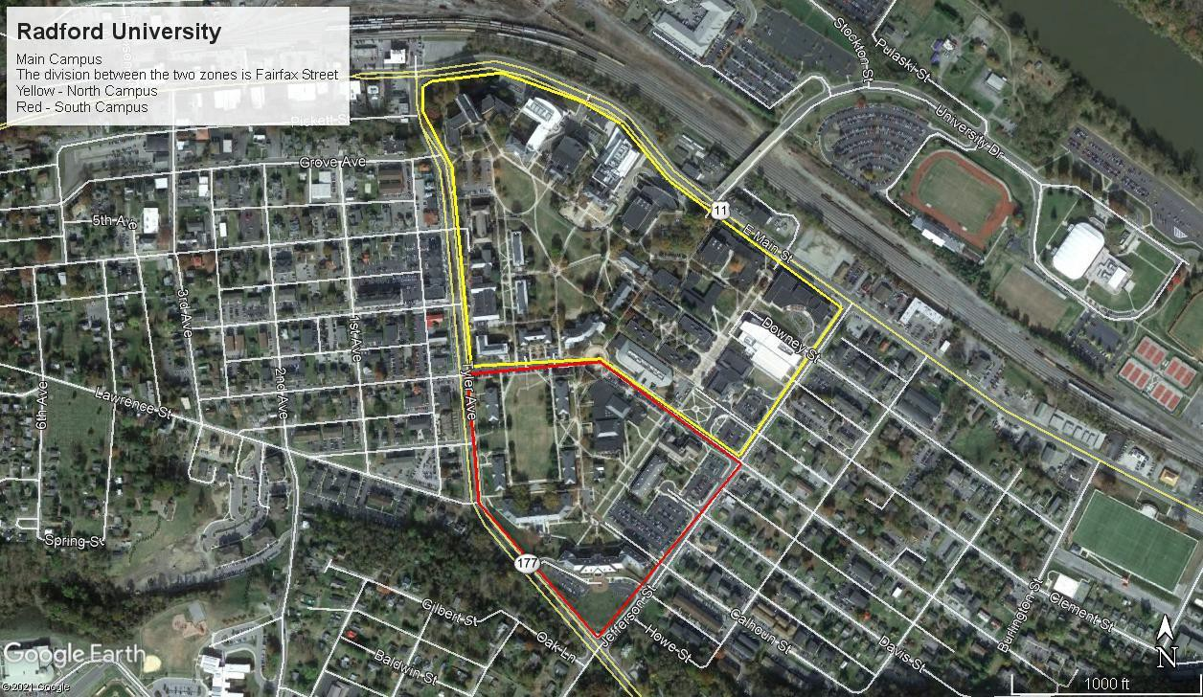

- | P a g e

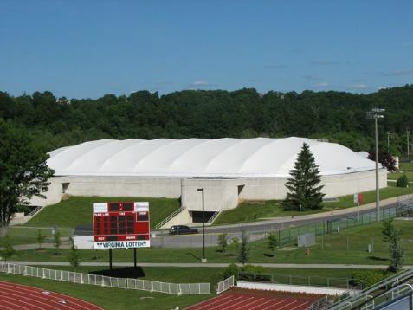
Dedmon Athletic Complex
Description
The Dedmon Athletic Complex is home to all of Radford’s NCAA and Intramural Sports. There are 10 sports fields, the Dedmon Center, Cupp Stadium, and multiple support buildings. The Armstrong Building, home of Radford Facilities Management, is also located in this area.
Location
The Dedmon Athletic Complex is located across Main Street from main campus between the New River and Railroad Tracks. It is accessed by crossing the bridge over the railroad on University Drive.
GPS Coordinates: 37.140585, -80.546630
Areas Managed
Two samples were taken from this area, one from around the Dedmon Center to represent the common areas on the eastern side of the complex. Samples were taken around the Armstrong Building to represent the common areas on the western side of the complex. The dividing line follows the western edge of Cupp Stadium. They are managed the same and both are cool season grass. The need for two samples was dictated by the size of the area. Soil test results will be combined into one recommendation. Sports fields, buildings, roads, and sidewalks were roughly measured using goggle earth and were subtracted from total acreage of 40.3 acres west and 63.9 acres east.
West Dedmon – Outlined in green. About 17 acres cool season turf. The predominate turf species is tall fescue.
East Dedmon – Outlined in blue. About 20 acres cool season turf. The predominate turf species is tall fescue.

- | P a g e

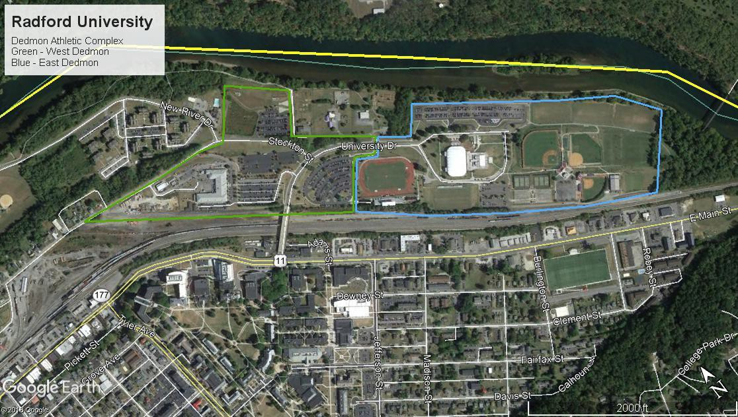

- | P a g e

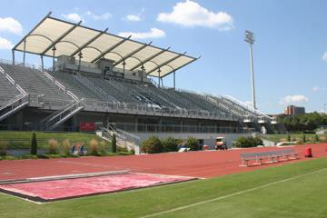
Cupp Stadium
Description
Patrick D. Cupp Memorial Stadium was completed in 2003 and quickly became one of the premier soccer and track and field stadiums in the Southeast. The largest soccer/track facility in the Big South Conference, Cupp Stadium has seating for 5,000 spectators. Four large locker rooms, an on-site athletic training room, and a
dedicated laundry room highlight the amenities for student-athletes and teams. The soccer surface is a Bermuda blend natural grass field. A state-of-the-art drainage system was recently added to assist in keeping the field in top shape year-round. The track is a synthetic surface divided into eight lanes. The stadium also includes jumping and vaulting pits.
Location
The Dedmon Athletic Complex is located across Main Street from main campus between the New River and Railroad Tracks. It is accessed by crossing the bridge over the railroad on University Drive. Cupp Stadium is first athletic field on the right.
GPS Coordinates: 37.139405, -80.544023
Areas Managed
Cupp Stadium is 2.3 acres of irrigated warm season turf. The soil is sand based with sand channel drainage (Cambridge). Outlined in blue. The predominate turf species is bermudagrass.

- | P a g e

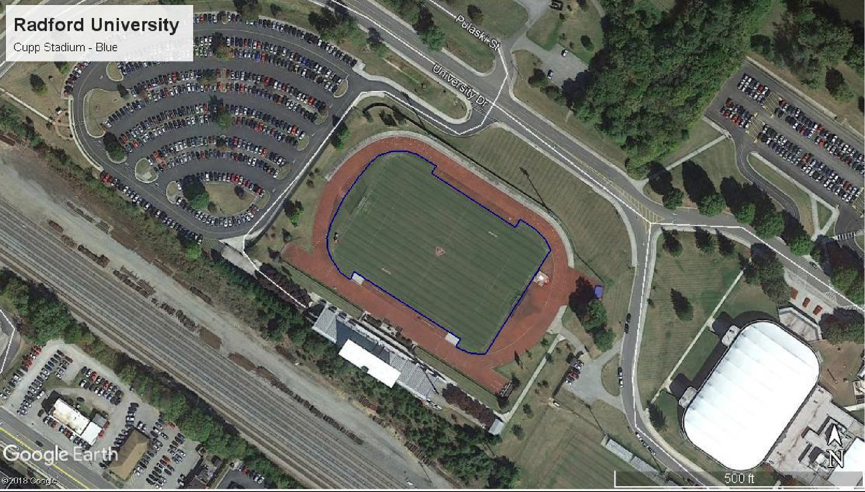

- | P a g e

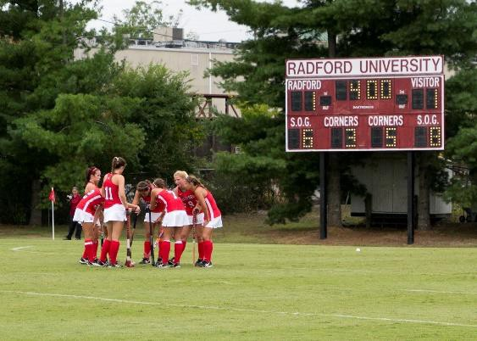
Field Hockey
Description
Radford University Field Hockey Field serves as home to the Radford University Field Hockey team. The field itself is natural grass, one of only two NorPac Conference fields to offer a natural playing surface. The fan side of the field offers seating for 1,000 fans, while the opposite side features the team benches, a scorer’s table area, a dedicated scoreboard and a video tower.
The field also features lights, allowing the team to practice or play after dark. Originially designed as RU's intercollegiate soccer field, the stadium was converted for Field Hockey-only use in 2002.
Location
The Dedmon Athletic Complex is located across Main Street from main campus between the New River and Railroad Tracks. It is accessed by crossing the bridge over the railroad on University Drive. After passing Cupp Stadium bear right between the Cupp Stadium and the Dedmon Center. The field hockey stadium is located to the right behind Dedmon.
GPS Coordinates: 37.137836, -80.542542
Areas Managed
The field is 2 acres of irrigated warm season turf. The soil is native (silt/clay) based with no drainage. Outlined in white. The predominate turf species is bermudagrass.

- | P a g e

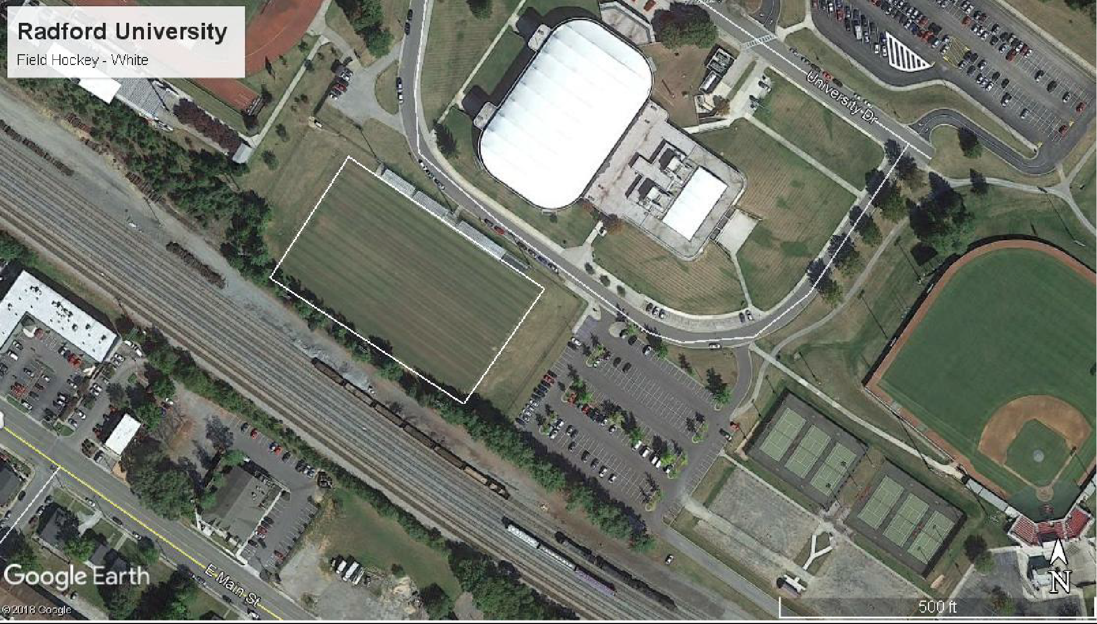

- | P a g e

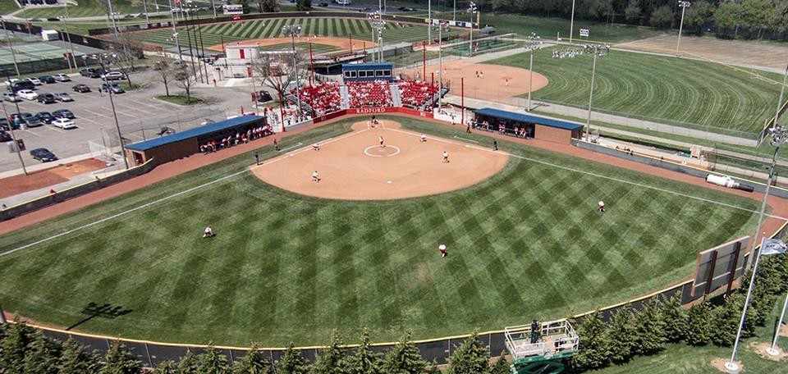
Softball
Description
The biggest renovation in the facility’s history was completed for the start of the 2014 campaign.
Located in the northeast corner of the Dedmon Center’s outdoor facilities, Radford Softball Stadium includes spacious, up-to-the-date dugouts, chairback stadium
seating, and a pressbox. In addition, a state-of-the-art sound system, along with upgrades to the bullpens and batting cages were included. Hosts of three Big South Tournaments and four nationally televised contests on the ESPN networks, RU’s facility upgrade allows the program to showcase its talents in a state-of-the-art stadium, while providing a better viewing for spectators and more efficient access for media, television, and radio. Radford opened the stadium on April 5 with a doubleheader sweep against Presbyterian and finished the year 11-3 in its new home. On April 26, the Athletics department held its official grand opening of RU Softball Stadium prior to a doubleheader versus Gardner-Webb
Location
The Dedmon Athletic Complex is located across Main Street from main campus between the New River and Railroad Tracks. It is accessed by crossing the bridge over the railroad on University Drive. After passing Cupp Stadium bear right between Cupp Stadium and the Dedmon Center. Continue behind the Dedmon Center and turn right into parking lot. Follow road to back of parking lot and then continue down drive between tennis courts and railroad. You will reach the parking lot serving the baseball stadium, softball stadium and upper/middle IM fields.
GPS Coordinates: 37.136617, -80.539089
Areas Managed
The softball field is 0.7 acres of irrigated warm season turf. The predominate turf species is bermudagrass. The soil is native (silt/clay) based with no drainage. Outlined in black.

- | P a g e

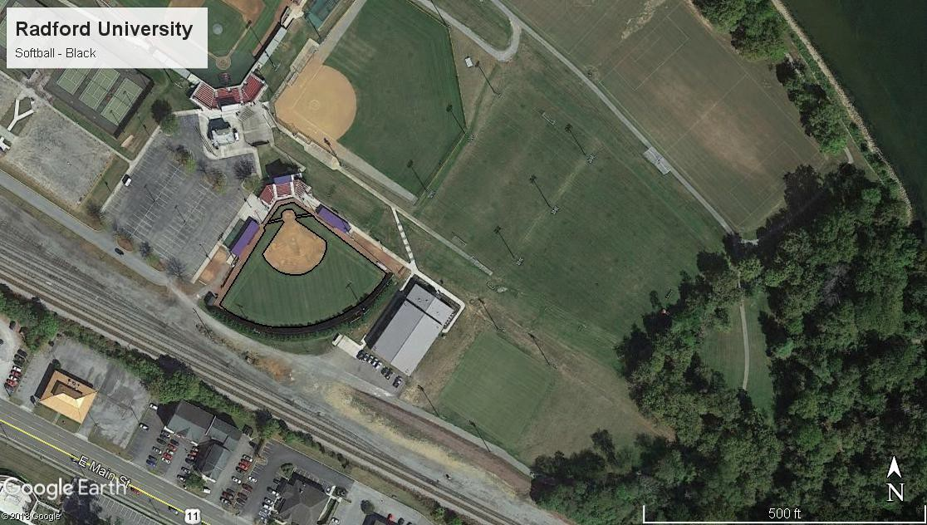

- | P a g e

Practice Fields
Description
Radford has two regulation size practices fields for field sports. There is also a turf area near the hitting facility that is used for baseball/softball activities.
Location
The Dedmon Athletic Complex is located across Main Street from main campus between the New River and Railroad Tracks. It is accessed by crossing the bridge over the railroad on University Drive. After passing Cupp Stadium continue straight past the Dedmon Center. At end of road bear left into parking lot. Practice fields are located on the lower level and adjacent to the new river. The fields are congruent and located beyond the rugby field, which is closest to the parking lot.
GPS Coordinates: 37.137104, -80.536729
Areas Managed
All three fields were included in one sample. They are 4.6 acres of warm season, irrigated turf. The soil is native (silt/clay) based with no drainage. Outlined in Red. The predominate turf species is bermudagrass

- | P a g e

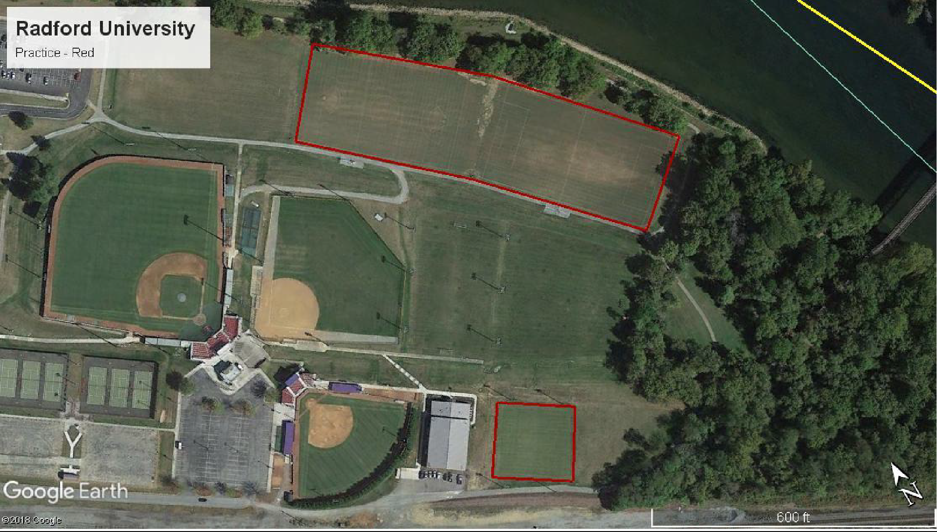

- | P a g e

IM Fields
Description
The Department of Student Recreation & Wellness operates several outdoor venues for various programming needsCurrently the department operates 3 natural turf fields (1 softball field and 2 multipurpose fields) located in the Dedmon Athletic complex. There is also a 7 acre artificial field located across the train tracks/Main St.
Location
The Dedmon Athletic Complex is located across Main Street from main campus between the New River and Railroad Tracks. It is accessed by crossing the bridge over the railroad on University Drive. After passing Cupp Stadium bear right between Cupp Stadium and the Dedmon Center. Continue behind the Dedmon Center and turn right into parking lot. Follow road to back of parking lot and then continue down drive between tennis courts and railroad. You will reach the parking lot serving the baseball stadium, softball stadium and upper/middle IM fields. Upper fields are located behind the softball field. Mid-level fields (softball and field) are located beside the baseball field. The lower level Rugby field can be accessed via the stairs between the baseball and IM softball field or from the parking lot below the Dedmon Center.
GPS Coordinates: 37.398389, -79.181010
Areas Managed
One sample was taken to represent all three fields. They are 6.5 acres of cool season irrigated turf. The soil is native (silt/clay) based with no drainage. Outlined in yellow. The predominate turf species is tall fescue.

- | P a g e

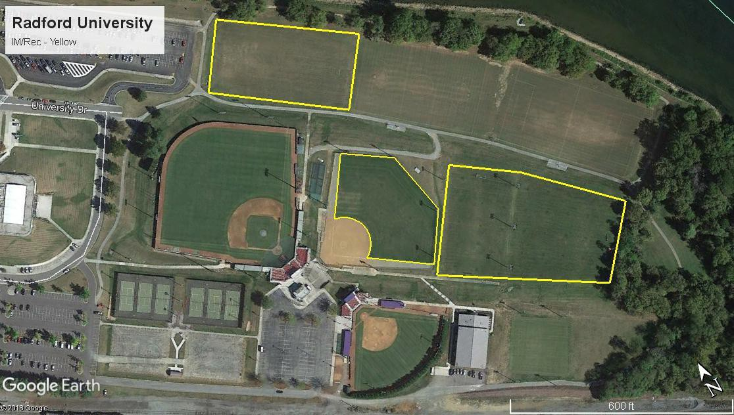

- | P a g e

IM/Rec Sports Common Area
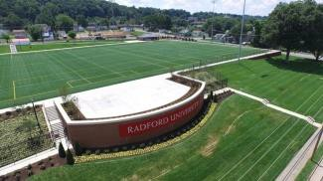
Description
The Department of Student Recreation & Wellness operates several outdoor venues to assist with our various programming needs. Opened Fall 2015 is a new 7 acre, fully lighted, Artificial Turf Field project that will accommodate flag football, soccer fields, and many other sports.
Also located at this site is the Russell Athletics Warehouse.
The turf area around sand volleyball and basketball courts has been added. Location
These areas are located to the east of main campus on Main Street.
Address: 219 East Main Street Radford, Virginia 24142
GPS Coordinates: 37.134628, -80.539878
Areas Managed
The 3.3 acres of common turf around the artificial athletic field and the warehouse are fertilized. This is all cool season turf. The predominate turf species is tall fescue.

- | P a g e

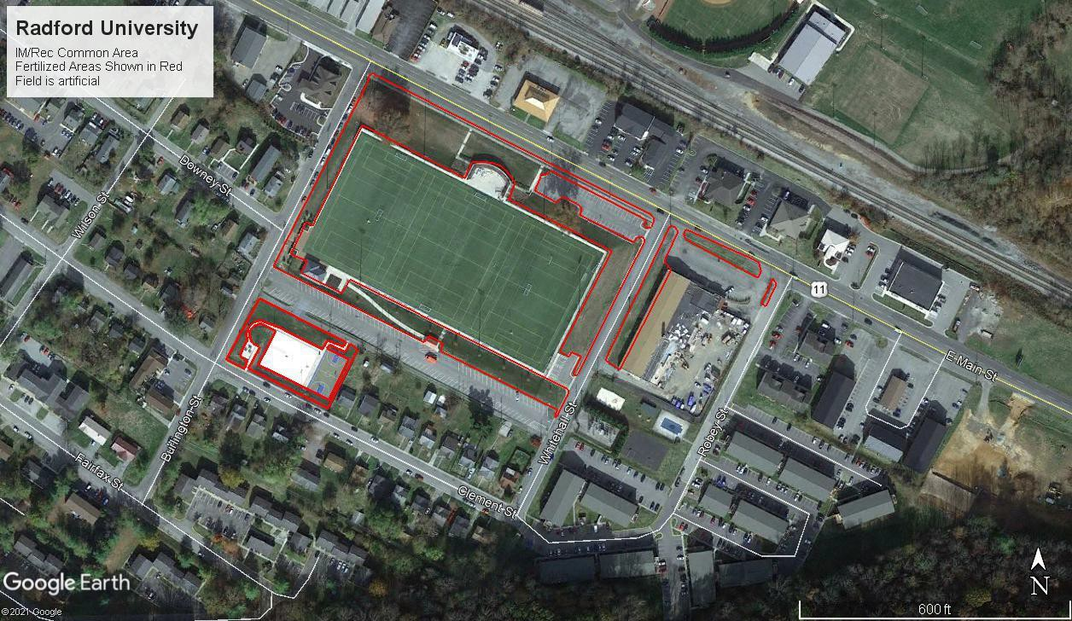

- | P a g e

Residential Area
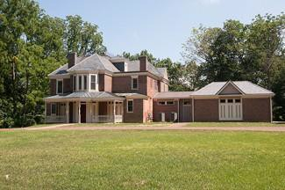
Description
915 Tyler Ave is the Presidents Home. The late Victorian/Queen Anne house, named Halwyck, located on Tyler Avenue in Radford, was built in 1892 and predates the founding of Radford University. The two- story brick dwelling was built by Virginia's 43rd governor, John Hoge Tyler (1846- 1925), and his wife Susan Montgomery Hammet Tyler (1845-1927), who were influential in the early development of the City of Radford when it emerged as a
railway hub and industrial center in Southwest Virginia.
905 Tyler Ave is no longer owned by the college.
Location
The home is located just before you reach the Radford campus near the intersection of Tyler Ave. and Jefferson St.
Address: 915 Tyler Ave., Radford, VA 24142 GPS Coordinates: 37.132045, -80.549040
Areas Managed
The 1.1 acres of cool season lawns around both homes are fertilized. The predominate turf species is tall fescue.

- | P a g e

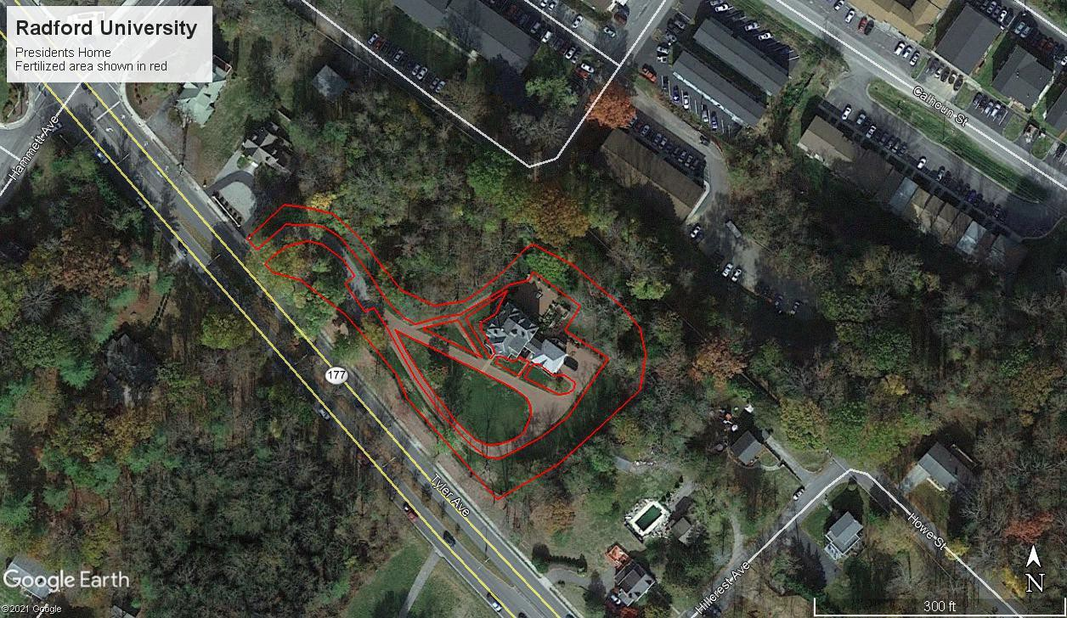

- | P a g e

Baseball
The Baseball field has been converted to artificial turf and has been removed from this plan.

Soil Test Summaries
Discussion of soil test results and allowable nutrient inputs. Specific applications details can be found in Nutrient Application Worksheet.
Soil tests are rated in terms of Very Low to Very High. To comply with Virginia Nutrient Management Standards and Criteria, Revised July 2014, no phosphorus may be applied if a soil test rates that element Very High. In economic terms, nutrients are not necessarily needed if they test above a medium rating; plant response is not guaranteed if soils already test above medium and therefore money can be saved by using a nitrogen only fertilizer. (See plant response chart page 69)
- There are three different types of turf in this plan. Irrigated cool season sports turf, cool season general turf and irrigated warm season sports turf. Each location has a different nitrogen need and application schedule and will have separate application worksheets and record sheets.
- Individual soil samples were provided for most locations. For those areas which were too large for 1 sample, “Limiting Results” will be used. Limiting results are the value which needs the least input. These results will be highlighted in the applicable tables.
- Application worksheets for each location and type of grass can be found in the
“Application Worksheet” section.

- For warm and cool season sports turf, application schedule and rates are based on DCR guidelines and must be followed as written. Large applications outside of these windows or more than these rates are not permitted.

- For cool season sports turf, soluble nitrogen rates of 0.25 #/M N or less may be applied as a part of a pesticide or minor element application and can be applied any time the turf is actively growing within the frost dates but must be considered part of the total annual nitrogen.

- All fertilizers suggested are granular, spray applications may be substituted. Labels for suggested fertilizers are located at the end of the document. Fertilizer analyses may be changed, but rates and slow release content must adhere to guidelines on the following descriptions for each type of turf.

- Plan will be written for maximum nitrogen input. The grounds manager will decide if all applications are needed by monitoring turf conditions.

- Lime is needed in some areas, see lime application chart for specifics.

Soil samples were taken by Robert Habel 0n 3/9/2021. Soil testing was conducted by Waypoint Analytical on 3/12/2021.

Soil Test Summary
Customer Name: |  | Radford University
Testing Lab: |  | Waypoint Analytical
Analysis Date: |  | 3/12/2021
Sample Date: |  | 3/9/2021
Planner Name |  | Five Oaks Agronomy Consulting
Certification Number |  | 654
Managed Area ID | Soil Test ID# | Soil pH | Buffer pH | Lab P2O5  (ppm) | VT P  (ppm) | VT (H/M/L) | Lab K2O (ppm) | VT K  (ppm) | VT (H/M/L)
Campus - North | RU 01 | 7.20 |  | 32 | 11.4 | M | 161 | 114.3 | H
Campus – South | RU 02 | 7.10 |  | 35 | 12.8 | M | 147 | 104.4 | H-
Dedmon – West | RU 03 | 7.00 |  | 26 | 8.6 | M- | 178 | 126.4 | H-
Dedmon – East | RU 04 | 6.60 |  | 17 | 4.5 | L | 95 | 67.5 | M
Cupp Stadium | RU 05 | 5.60 | 6.86 | 50 | 19.6 | H- | 52 | 36.9 | M
Field Hockey | RU 06 | 5.60 | 6.81 | 66 | 27.0 | H- | 121 | 85.9 | M+
Softball | RU 07 | 5.60 | 6.84 | 35 | 12.8 | M | 91 | 64.6 | M
Practice Fields – Upper | RU 08 | 7.00 |  | 35 | 12.8 | M | 71 | 50.4 | M-
IM Middle, Softball, | RU 09 | 6.50 |  | 26 | 8.6 | M- | 125 | 88.8 | H-
IM/Rec Sports Complex | RU 10 | 6.80 |  | 22 | 6.8 | M- | 131 | 93.0 | H-
Residential Area | RU 11 | 7.00 |  | 31 | 10.9 | M- | 137 | 97.3 | H-

Main Campus
All areas of general turf may receive 3.5 #/M nitrogen per year. If using 100% water-soluble nitrogen 0.7 #/M may be applied every 30 days. If using slow release materials, 0.9 #/M may be used every 30 days. Do not exceed stated per year total. These applications may be made at any time within the frost-free dates if the turf is actively growing. A program weighted towards fall applications is recommended.
Soil test Limiting Results were medium (M) levels of phosphorus and high (H-) levels of potassium. 1.5 #/M of phosphorus will be allowed. 1 #/M potassium is called for, but more can be applied as potassium does not pose a water quality risk.
Lime is not needed at this time.

Customer Name: |  | Radford University
Testing Lab: |  | Waypoint Analytical
Sample Date: |  | 2/8/2018
Testing Date: |  | 2/1/2018
Managed Area ID | Soil Test ID | Soil pH | Buffer pH | Lab P (ppm) | VT P  (ppm) | VT (H/M/L) | Lab K (ppm) | VT K  (ppm) | VT (H/M/L)
Campus - North | RU 01 | 7.20 |  | 32 | 11.4 | M | 161 | 114.3 | H
Campus – South | RU 02 | 7.10 |  | 35 | 12.8 | M | 147 | 104.4 | H-
Limiting Results |  |  |  |  | 12.8 | M |  | 114.3 | H-
DCR Allowed Input (#/M) |  | Lime: | 0 |  | P: | 1.5 |  | K: | 1

Dedmon Athletic Complex
All areas of general turf may receive 3.5 #/M nitrogen per year. If using 100% water-soluble nitrogen 0.7 #/M may be applied every 30 days. If using slow release materials, 0.9 #/M may be used every 30 days. Do not exceed stated per year total. These applications may be made at any time within the frost-free dates if the turf is actively growing. A program weighted towards fall applications is recommended.
Soil test Limiting Results were medium (M-) levels of phosphorus and high (H-) levels of potassium. 2 #/M of phosphorus will be allowed. 1 #/M potassium is called for, but more can be applied as potassium does not pose a water quality risk.

Customer Name: |  | Radford University
Testing Lab: |  | Waypoint Analytical
Sample Date: |  | 2/8/2018
Testing Date: |  | 2/1/2018
Managed Area ID | Soil Test ID | Soil pH | Buffer pH | Lab P (ppm) | VT P  (ppm) | VT (H/M/L) | Lab K (ppm) | VT K  (ppm) | VT (H/M/L)
Dedmon – West | RU 03 | 7.00 |  | 26 | 8.6 | M- | 178 | 126.4 | H-
Dedmon – East | RU 04 | 6.60 |  | 17 | 4.5 | L | 95 | 67.5 | M
Limiting Results |  |  |  |  | 8.6 | M- |  | 126.4 | H-
DCR Allowed Input (#/M) |  | Lime: | 0 |  | P: | 2 |  | K: | 1

Cupp Stadium
5 #/M nitrogen allowed per year on this irrigated warm season field with an additional 1 #/M allowed for overseeding.
- Water Soluble Nitrogen must be applied as two applications not to exceed 0.35 #/M each with a minimum of 15 days between applications. Alternatively, using a material that contains at least 15% slowly available nitrogen sources, split applications of 0.5 #/M may be applied with a minimum of 15 days between applications.
- For overseeded warm season turf, if using a minimum of 15% slow release N, a max of 1#/M N may be used. Applications of 0.5 #/M may be applied in spring and fall. If using less than 15% slow release N, a max of 0.7 #/M N may be used. Applications of 0.35 #/M may be applied in spring and fall.
- Do not exceed stated per year total.
- These applications must be made within this time frame.
Soil test shows high (H-) levels of phosphorus and medium (M) levels of potassium. 1 #/M of phosphorus is allowed. 1.5 #/M potassium is called for, but more can be applied as potassium does not pose a water quality risk.
The buffer pH is 6.86. According to the soil test report recommendations, 23 #/M of dolomitic lime is needed. Attempt to apply at aeration.

Customer Name: |  | Radford University
Testing Lab: |  | Waypoint Analytical
Sample Date: |  | 2/8/2018
Testing Date: |  | 2/1/2018
Managed Area ID | Soil Test ID | Soil pH | Buffer pH | Lab P (ppm) | VT P  (ppm) | VT (H/M/L) | Lab K (ppm) | VT K  (ppm) | VT (H/M/L)
Cupp Stadium | RU 05 | 5.60 | 6.86 | 50 | 19.6 | H- | 52 | 36.9 | M
DCR Allowed Input (#/M) |  | Lime: | 0.5 T/A |  | P: | 1 |  | K: | 1.5

Field Hockey
5 #/M nitrogen allowed per year on this irrigated warm season field with an additional 1 #/M allowed for overseeding.
- Applications of nitrogen occurring outside of the summer months (Sep-May) must be split. Water-soluble nitrogen or products with less than 15% slowly available nitrogen must be applied with a per-application maximum of 0.35 #/M and a minimum of 15 days between applications. Products with 15% or greater slowly available nitrogen may be applied with a per-application maximum of 0.5 #/M and a minimum of 15 days between applications.
- Applications made during the summer months (Jun-Aug) have higher allowable application rates. Applications of water soluble nitrogen or products with less than 15% slowly available nitrogen must be applied with a per-application max of 0.7 #/M and a minimum of 30 days between applications. Products with 15% or greater slowly available nitrogen may be applied with a per-application max of 1 #/M.
- Do not exceed stated per year total.
- These applications must be made within this time frame.
Soil test shows high (H-) levels of phosphorus and medium (M+) levels of potassium. 1 #/M of phosphorus is allowed. 1 #/M potassium is called for, but more can be applied as potassium does not pose a water quality risk.
The buffer pH is 6.81. According to the soil test report recommendations, 46 #/M of dolomitic lime is needed. Attempt to apply at aeration.

Customer Name: |  | Radford University
Testing Lab: |  | Waypoint Analytical
Sample Date: |  | 2/8/2018
Testing Date: |  | 2/1/2018
Managed Area ID | Soil Test ID | Soil pH | Buffer pH | Lab P (ppm) | VT P  (ppm) | VT (H/M/L) | Lab K (ppm) | VT K  (ppm) | VT (H/M/L)
Field Hockey | RU 06 | 5.60 | 6.81 | 66 | 27.0 | H- | 121 | 85.9 | M+
DCR Allowed Input (#/M) |  | Lime: | 1 T/A |  | P: | 1 |  | K: | 1

Softball
5 #/M nitrogen allowed per year on this irrigated warm season field with an additional 1 #/M allowed for overseeding.
- Applications of nitrogen occurring outside of the summer months (Sep-May) must be split. Water-soluble nitrogen or products with less than 15% slowly available nitrogen must be applied with a per-application maximum of 0.35 #/M and a minimum of 15 days between applications. Products with 15% or greater slowly available nitrogen may be applied with a per-application maximum of 0.5 #/M and a minimum of 15 days between applications.
- Applications made during the summer months (Jun-Aug) have higher allowable application rates. Applications of water soluble nitrogen or products with less than 15% slowly available nitrogen must be applied with a per-application max of 0.7 #/M and a minimum of 30 days between applications. Products with 15% or greater slowly available nitrogen may be applied with a per-application max of 1 #/M.
- Do not exceed stated per year total.
- These applications must be made within this time frame.
Soil test shows medium (M) levels of phosphorus and medium (M) levels of potassium. 1.5 #/M of phosphorus is allowed. 1.5 #/M potassium is called for, but more can be applied as potassium does not pose a water quality risk.
The buffer pH is 6.84. According to the soil test report recommendations, 46 #/M of dolomitic lime is needed. Attempt to apply at aeration.

Customer Name: |  | Radford University
Testing Lab: |  | Waypoint Analytical
Sample Date: |  | 2/8/2018
Testing Date: |  | 2/1/2018
Managed Area ID | Soil Test ID | Soil pH | Buffer pH | Lab P (ppm) | VT P  (ppm) | VT (H/M/L) | Lab K (ppm) | VT K  (ppm) | VT (H/M/L)
Softball | RU 07 | 5.60 | 6.84 | 35 | 12.8 | M | 91 | 64.6 | M
DCR Allowed Input (#/M) |  | Lime: | 1 T/A |  | P: | 1.5 |  | K: | 1.5

Practice Fields
5 #/M nitrogen allowed per year on this irrigated warm season field with an additional 1 #/M allowed for overseeding.
- Applications of nitrogen occurring outside of the summer months (Sep-May) must be split. Water-soluble nitrogen or products with less than 15% slowly available nitrogen must be applied with a per-application maximum of 0.35 #/M and a minimum of 15 days between applications. Products with 15% or greater slowly available nitrogen may be applied with a per-application maximum of 0.5 #/M and a minimum of 15 days between applications.
- Applications made during the summer months (Jun-Aug) have higher allowable application rates. Applications of water soluble nitrogen or products with less than 15% slowly available nitrogen must be applied with a per-application max of 0.7 #/M and a minimum of 30 days between applications. Products with 15% or greater slowly available nitrogen may be applied with a per-application max of 1 #/M.
- Do not exceed stated per year total.
- These applications must be made within this time frame.
Soil test shows medium (M) levels of phosphorus and medium (M-) levels of potassium. 1.5 #/M of phosphorus is allowed. 2 #/M potassium is called for, but more can be applied as potassium does not pose a water quality risk.
Lime is not needed at this time.

Customer Name: |  | Radford University
Testing Lab: |  | Waypoint Analytical
Sample Date: |  | 2/8/2018
Testing Date: |  | 2/1/2018
Managed Area ID | Soil Test ID | Soil pH | Buffer pH | Lab P (ppm) | VT P  (ppm) | VT (H/M/L) | Lab K (ppm) | VT K  (ppm) | VT (H/M/L)
Practice Fields –  Upper and Lower | RU 08 | 7.00 |  | 35 | 12.8 | M | 71 | 50.4 | M-
DCR Allowed Input (#/M) |  | Lime: | 0 |  | P: | 1.5 |  | K: | 2

IM Fields
- 2 #/M nitrogen allowed per year on this irrigated cool season field. For September through November applications, if using 100% water-soluble nitrogen 0.7 #/M may be applied every 30 days. If using slow release materials, 0.9 #/M may be used every 30 days. For applications made from April to August, the maximum application rat is 0.5 #/M every 30 days. Do not exceed stated per year total. These applications must be made within this time frame, see footnote D on page 34 for exceptions.
Soil test results were medium (M-) levels of phosphorus and high (H-) levels of potassium. 2 #/M of phosphorus is allowed. 1 #/M potassium is called for, but more can be applied as potassium does not pose a water quality risk.
Lime is not needed at this time.

Customer Name: |  | Radford University
Testing Lab: |  | Waypoint Analytical
Sample Date: |  | 2/8/2018
Testing Date: |  | 2/1/2018
Managed Area ID | Soil Test ID | Soil pH | Buffer pH | Lab P (ppm) | VT P  (ppm) | VT (H/M/L) | Lab K (ppm) | VT K  (ppm) | VT (H/M/L)
IM Middle, Softball, Rugby | RU 09 | 6.50 |  | 26 | 8.6 | M- | 125 | 88.8 | H-
DCR Allowed Input (#/M) |  | Lime: | 0 |  | P: | 2 |  | K: | 1

IM/Rec Sports Common Area
All areas of general turf may receive 3.5 #/M nitrogen per year. If using 100% water-soluble nitrogen 0.7 #/M may be applied every 30 days. If using slow release materials, 0.9 #/M may be used every 30 days. Do not exceed stated per year total. These applications may be made at any time within the frost-free dates if the turf is actively growing. A program weighted towards fall applications is recommended.
Soil test results show medium (M-) levels of phosphorus and high (H-) levels of potassium. 2 #/M of phosphorus is allowed. 1 #/M potassium is called for, but more can be applied as potassium does not pose a water quality risk.
Lime is not needed at this time.

Customer Name: |  | Radford University
Testing Lab: |  | Waypoint Analytical
Sample Date: |  | 2/8/2018
Testing Date: |  | 2/1/2018
Managed Area ID | Soil Test ID | Soil pH | Buffer pH | Lab P (ppm) | VT P  (ppm) | VT (H/M/L) | Lab K (ppm) | VT K  (ppm) | VT (H/M/L)
IM/Rec Sports Common Area | RU 10 | 6.80 |  | 22 | 6.8 | M- | 131 | 93.0 | H-
DCR Allowed Input (#/M) |  | Lime: | 0 |  | P: | 2 |  | K: | 1

Residential
All areas of general turf may receive 3.5 #/M nitrogen per year. If using 100% water-soluble nitrogen 0.7 #/M may be applied every 30 days. If using slow release materials, 0.9 #/M may be used every 30 days. Do not exceed stated per year total. These applications may be made at any time within the frost-free dates if the turf is actively growing. A program weighted towards fall applications is recommended.
Soil test results show medium (M-) levels of phosphorus and high (H-) levels of potassium. 2 #/M of phosphorus is allowed. 1 #/M potassium is called for, but more can be applied as potassium does not pose a water quality risk. Lime is not needed at this time.

Customer Name: |  | Radford University
Testing Lab: |  | Waypoint Analytical
Sample Date: |  | 2/8/2018
Testing Date: |  | 2/1/2018
Managed Area ID | Soil Test ID | Soil pH | Buffer pH | Lab P (ppm) | VT P  (ppm) | VT (H/M/L) | Lab K (ppm) | VT K  (ppm) | VT (H/M/L)
Residential Area | RU 11 | 7.00 |  | 31 | 10.9 | M- | 137 | 97.3 | H-
DCR Allowed Input (#/M) |  | Lime: | 0 |  | P: | 2 |  | K: | 1

Nutrient Application Worksheets
The following worksheets detail specific fertilizer applications using the previously discussed soil test information. All nutrient input level recommendations come from the Department of Conservation and Recreation’s Nutrient Management Standards and Criteria, this document is part of the Code of Virginia and thus is law for those required to have a Nutrient Management Plan. While applications do not have to be followed specifically, it is important to note that per month nitrogen levels shall not be exceeded and per year phosphorus levels shall not be exceeded. In some cases, potassium input may exceed recommended levels, as it does not have the same detrimental effects on the health of Virginia’s waters as nitrogen and phosphorus. Potassium is considered the plant nutrient most responsible for quality. It
helps plants respond to stresses like drought, extreme heat/cold, and insect/disease pressure. The plants increased ability to respond to stress in a positive manner can help reduce the need for increased N and P fertility and reseeding caused by stress.

- Specific fertilizers have been recommended. Fertilizer analyses are subject to change dependent on availability, suppliers chosen, etc. It is your responsibility to choose fertilizers and calculate appropriate rates that follow discussed regulations. Do not exceed stated monthly Total N or yearly total P. Please contact your planner if you need help adjusting a fertilizer application to meet the requirements of this plan. A spreadsheet to help calculate rates is available on provided flash drive.

- Making fertilizer applications without calibrating your equipment will lead to inaccurate applications. Application rates (# product/M) and amount of product needed per application (lb/app) are included in spreadsheet.

- Please stay within dates indicated on spreadsheets.

- Class B bio-solids and animal manures cannot be used without revising this plan to reflect the appropriate setbacks and environmental hazards. Class A bio-solids like Milorganite can be used without problem.

- Potassium applications have been exceeded. Potassium helps protect the plant from stress and poses no threat to water quality.

- Fertilizer labels of products chosen are located at end of document.

- All applications are shown in #/M.

Main Campus

Notes:
    - Tested M in Phosphorus and H- Potassium.
    - Application rates are based on use of at least 15% slow release fertilizer. 0.9 #/M N allowed if using at least 15% slow release nitrogen. If using less than 15% only 0.7 #/M nitrogen allowed.

Dedmon Athletic Complex
NUTRIENT APPLICATION WORK SHEET
Name: | Radford University |  |  | Management Area (acres): | Dedmon Athletic Complex - East and West Zones
Prepared: | 6/1/2021 |  |  | Area: | 37 |  | Turf Type: |  |  |  | Cool Season General Turf
Expires: | 6/1/2024
Total Yearly Nutrient Needs | AppliCation Month/Day | Analysis | Interval (days) | Fertilizer Description | Rate/M | lbs/app | % Slow Release N | Total/M |  |  |  |  | Lime | Gypsum | lbs/app lime/gyp
 |  | N - P - K |  |  |  |  |  | N | - | P | - | K | lbs/M
Nitrogen | No applications before March 5
3.5 | March | 16 - 3 - 8 | 30 | 16-3-8 50%XCU 20%Biosolids 2%Fe | 5.31 | 8558 | 55 | 0.85 | - | 0.16 | - | 0.42
Phosphorus
2 | May | 16 - 3 - 8 | 30 | 16-3-8 50%XCU 20%Biosolids 2%Fe | 5.31 | 8558 | 55 | 0.85 | - | 0.16 | - | 0.42
Potassium
1 | August | 16 - 3 - 8 | 30 | 16-3-8 50%XCU 20%Biosolids 2%Fe | 5.63 | 9074 | 55 | 0.90 | - | 0.17 | - | 0.45
 | November | 16 - 3 - 8 | 30 | 16-3-8 50%XCU 20%Biosolids 2%Fe | 5.63 | 9074 | 55 | 0.90 | - | 0.17 | - | 0.45
 | No applications after December 4
 | Lime
 | See lime application sheet
 |  |  |  |  |  | Total used: |  | 3.50 | - | 0.66 | - | 1.74
 |  |  |  | Do not exceed yearly maximum allowed by Regulation (Except for K): |  |  |  | 3.5 | - | 2 | - | 1

Notes:
    - Tested M- in Phosphorus and H- Potassium.
    - Application rates are based on use of at least 15% slow release fertilizer. 0.9 #/M N allowed if using at least 15% slow release nitrogen. If using less than 15% only 0.7 #/M nitrogen allowed.

Cupp Stadium
NUTRIENT APPLICATION WORK SHEET
Name: | Radford University |  |  | Management Area: | Cupp Stadium
Prepared: | 6/1/2021 |  |  | Area: | 2.3 |  | Turf Type: |  | Warm Season Irrigated  Sports Turf
Expires: | 6/1/2024
Total Yearly Nutrient Needs | Application Month/Day | Analysis  N - P - K | Interval (days) | Fertilizer Description | Rate/M | lbs/app | % Slow Release N | Total/M  N - P - K |  | Lime | Gypsum | lbs/app lime/gyp
 |  |  |  |  |  |  |  |  |  | lbs/M
Nitrogen | No applications before April 16 on warm season turf. If turf is overseeded, no applications before March 5.
5 | March | 32 - 0 - 7 | 30 | Southern Lawn 32-0-7 32% XRT | 1.56 | 156 | 32 | 0.50 - 0.00 - 0.11
Phosphorus
1 | After April 16 | 16 - 3 - 8 | 30 | 16-3-8 50%XCU 20%Biosolids 2%Fe | 3.13 | 314 | 55 | 0.50 - 0.09 - 0.25
Potassium
1.5 | May | 16 - 3 - 8 | 30 | 16-3-8 50%XCU 20%Biosolids 2%Fe | 3.13 | 314 | 55 | 0.50 - 0.09 - 0.25
 | June | 16 - 3 - 8 | 30 | 16-3-8 50%XCU 20%Biosolids 2%Fe | 6.25 | 626 | 55 | 1.00 - 0.19 - 0.50
 | July | 16 - 3 - 8 | 30 | 16-3-8 50%XCU 20%Biosolids 2%Fe | 6.25 | 626 | 55 | 1.00 - 0.19 - 0.50
 | August | 16 - 3 - 8 | 30 | 16-3-8 50%XCU 20%Biosolids 2%Fe | 6.25 | 626 | 55 | 1.00 - 0.19 - 0.50
 | Sept 1 - Sept 15 | 16 - 3 - 8 | 30 | 16-3-8 50%XCU 20%Biosolids 2%Fe | 6.25 | 0 | 55 | 1.00 - 0.19 - 0.50
 | Oct-Nov | 32 - 0 - 7 | 30 | Southern Lawn 32-0-7 32% XRT | 1.56 | 156 | 32 | 0.50 - 0.00 - 0.11
 | No applications after September 23 on warm season turf. If turf is overseeded, no applications after December 4.
 | Lime
 | Fall 2021 - 1 Application of 0.5 T/A Dolmitic Limestone |  |  |  |  |  |  |  |  | 23 |  | 2,304
Overseeding | Make these applications only if turf has been overseeded.
Add 1 #/M N |  |  |  |  |  | Total used: |  | 6.00 - 0.94 - 2.72
 | Do not exceed yearly maximum allowed by Regulation (Except for K): |  |  |  |  |  |  | 5 - 1 - 1.5

Notes:
    - Tested H- in Phosphorus and M Potassium.
- Applications of nitrogen occurring outside of the summer months (Sep-May) must be split. Water-soluble nitrogen or products with less than 15% slowly available nitrogen must be applied with a per-application maximum of 0.35 #/M and a minimum of 15 days between

- For overseeded warm season turf, if using a minimum of 15% slow release N, a max of 1#/M N may be used. Applications of 0.5 #/M may be applied in spring and fall. If using less than 15% slow release N, a max of 0.7 #/M N may be used. Applications of 0.35 #/M may be applied in spring and fall.
- Applications made during the summer months (Jun-Aug) have higher allowable application rates. Applications of water soluble nitrogen or products with less than 15% slowly available nitrogen must be applied with a per-application max of 0.7 #/M and a minimum of 30 days between applications. Products with 15% or greater slowly available nitrogen may be applied with a per-application max of 1 #/M.
applications. Products with 15% or greater slowly available nitrogen may be applied with a per-application maximum of 0.5 #/M and a minimum of 15 days between applications.

Field Hockey
NUTRIENT APPLICATION WORK SHEET
Name: | Radford University |  |  | Management Area: | Field Hockey
Prepared: | 6/1/2021 |  |  | Area: | 2 |  | Turf Type: |  | Warm Season Irrigated  Sports Turf
Expires: | 6/1/2024
Total Yearly Nutrient Needs | Application Month/Day | Analysis  N - P - K | Interval (days) | Fertilizer Description | Rate/M | lbs/app | % Slow Release N | Total/M  N - P - K |  | Lime | Gypsum | lbs/app lime/gyp
 |  |  |  |  |  |  |  |  |  | lbs/M
Nitrogen | No applications before April 16 on warm season turf. If turf is overseeded, no applications before March 5.
5 | March | 32 - 0 - 7 | 30 | Southern Lawn 32-0-7 32% XRT | 1.56 | 136 | 32 | 0.50 - 0.00 - 0.11
Phosphorus
1 | After April 16 | 16 - 3 - 8 | 30 | 16-3-8 50%XCU 20%Biosolids 2%Fe | 3.13 | 273 | 55 | 0.50 - 0.09 - 0.25
Potassium
1 | May | 16 - 3 - 8 | 30 | 16-3-8 50%XCU 20%Biosolids 2%Fe | 3.13 | 273 | 55 | 0.50 - 0.09 - 0.25
 | June | 16 - 3 - 8 | 30 | 16-3-8 50%XCU 20%Biosolids 2%Fe | 6.25 | 545 | 55 | 1.00 - 0.19 - 0.50
 | July | 16 - 3 - 8 | 30 | 16-3-8 50%XCU 20%Biosolids 2%Fe | 6.25 | 545 | 55 | 1.00 - 0.19 - 0.50
 | August | 16 - 3 - 8 | 30 | 16-3-8 50%XCU 20%Biosolids 2%Fe | 6.25 | 545 | 55 | 1.00 - 0.19 - 0.50
 | Sept 1 - Sept 15 | 16 - 3 - 8 | 30 | 16-3-8 50%XCU 20%Biosolids 2%Fe | 6.25 | 0 | 55 | 1.00 - 0.19 - 0.50
 | Oct-Nov | 32 - 0 - 7 | 30 | Southern Lawn 32-0-7 32% XRT | 1.56 | 136 | 32 | 0.50 - 0.00 - 0.11
 | No applications after September 23 on warm season turf. If turf is overseeded, no applications after December 4.
 | Lime
 | Fall 2021 - 1 Application of 1 T/A Dolmitic Limestone |  |  |  |  |  |  |  |  | 46 |  | 4,008
Overseeding | Make these applications only if turf has been overseeded.
Add 1 #/M N |  |  |  |  |  | Total used: |  | 6.00 - 0.94 - 2.72
 | Do not exceed yearly maximum allowed by Regulation (Except for K): |  |  |  |  |  |  | 5 - 1 - 1

Notes:
    - Tested H- in Phosphorus and M+ Potassium.
- Applications of nitrogen occurring outside of the summer months (Sep-May) must be split. Water-soluble nitrogen or products with less than 15% slowly available nitrogen must be applied with a per-application maximum of 0.35 #/M and a minimum of 15 days between

- For overseeded warm season turf, if using a minimum of 15% slow release N, a max of 1#/M N may be used. Applications of 0.5 #/M may be applied in spring and fall. If using less than 15% slow release N, a max of 0.7 #/M N may be used. Applications of 0.35 #/M may be applied in spring and fall.
- Applications made during the summer months (Jun-Aug) have higher allowable application rates. Applications of water soluble nitrogen or products with less than 15% slowly available nitrogen must be applied with a per-application max of 0.7 #/M and a minimum of 30 days between applications. Products with 15% or greater slowly available nitrogen may be applied with a per-application max of 1 #/M.
applications. Products with 15% or greater slowly available nitrogen may be applied with a per-application maximum of 0.5 #/M and a minimum of 15 days between applications.

Softball

Name:

Radford University

NUTRIENT APPLICATION WORK SHEET
Management Area:

Softball

Prepared: Expires:
6/1/2021
6/1/2024

Area:

0.7

Turf Type:
Warm Season I Sp

Total Yearly Nutrient Needs
Application Month/Day
Analysis N - P - K
Interval (days)
Fertilizer Description
Rate/M
lbs/app
% Slow Release N
Total/M
N - P -

Nitrogen No applications before April 16 on warm season turf. If turf is overseeded, no applications before March 5.
5 | March | 32 | - 0 | - | 7 | 30 | Southern Lawn 32-0-7 32% XRT | 1.56 | 48 | 32 | 0.50
Phosphorus
1.5 | After April 16 | 16 | - 3 | - | 8 | 30 | 16-3-8 50%XCU 20%Biosolids 2%Fe | 3.13 | 95 | 5
Potassium
1.5 | May | 16 | - 3 | - | 8 | 30 | 16-3-8 50%XCU 20%Biosolids 2%Fe | 3.13 | 9
 | June | 16 | - 3 | - | 8 | 30 | 16-3-8 50%XCU 20%Biosolids 2%Fe
 | July | 16 | - 3 | - | 8 | 30 | 16-3-8 50%XCU 20%Bios
 | August | 16 | - 3 | - | 8 | 30 | 16-3-8 50%
 | Sept 1 - Sept 15 | 16 | - 3 | - | 8 | 30
 | Oct-Nov | 32 | - 0 | - | 7

No ap
Lime

Overseeding
Add 1 #

Notes:
- Tested M in Phosphorus and M Potassium.
- Applications of nitrogen occurring outside of the summer months (Sep-May) must be split. Water-soluble nitrogen or products with less than 15% slowly available nitrogen must be applied with a per-application maximum of 0.35 #/M and a minimum of 15 days between

- For overseeded warm season turf, if using a minimum of 15% slow release N, a max of 1#/M N may be used. Applications of 0.5 #/M may be applied in spring and fall. If using less than 15% slow release N, a max of 0.7 #/M N may be used. Applications of 0.35 #/M may be applied in spring and fall.
- Applications made during the summer months (Jun-Aug) have higher allowable application rates. Applications of water soluble nitrogen or products with less than 15% slowly available nitrogen must be applied with a per-application max of 0.7 #/M and a minimum of 30 days between applications. Products with 15% or greater slowly available nitrogen may be applied with a per-application max of 1 #/M.
applications. Products with 15% or greater slowly available nitrogen may be applied with a per-application maximum of 0.5 #/M and a minimum of 15 days between applications.

Practice Fields
NUTRIENT APPLICATION WORK SHEET
Name: | Radford University |  |  | Management Area: | Practice Fields
Prepared: | 6/1/2021 |  |  | Area: | 4.6 |  | Turf Type: |  | Warm Season Irrigated  Sports Turf
Expires: | 6/1/2024
Total Yearly Nutrient Needs | Application Month/Day | Analysis  N - P - K | Interval (days) | Fertilizer Description | Rate/M | lbs/app | % Slow Release N | Total/M  N - P - K |  | Lime | Gypsum | lbs/app lime/gyp
 |  |  |  |  |  |  |  |  |  | lbs/M
Nitrogen | No applications before April 16 on warm season turf. If turf is overseeded, no applications before March 5.
5 | March | 32 - 0 - 7 | 30 | Southern Lawn 32-0-7 32% XRT | 1.56 | 313 | 32 | 0.50 - 0.00 - 0.11
Phosphorus
1.5 | After April 16 | 16 - 3 - 8 | 30 | 16-3-8 50%XCU 20%Biosolids 2%Fe | 3.13 | 627 | 55 | 0.50 - 0.09 - 0.25
Potassium
2 | May | 16 - 3 - 8 | 30 | 16-3-8 50%XCU 20%Biosolids 2%Fe | 3.13 | 627 | 55 | 0.50 - 0.09 - 0.25
 | June | 16 - 3 - 8 | 30 | 16-3-8 50%XCU 20%Biosolids 2%Fe | 6.25 | 1252 | 55 | 1.00 - 0.19 - 0.50
 | July | 16 - 3 - 8 | 30 | 16-3-8 50%XCU 20%Biosolids 2%Fe | 6.25 | 1252 | 55 | 1.00 - 0.19 - 0.50
 | August | 16 - 3 - 8 | 30 | 16-3-8 50%XCU 20%Biosolids 2%Fe | 6.25 | 1252 | 55 | 1.00 - 0.19 - 0.50
 | Sept 1 - Sept 15 | 16 - 3 - 8 | 30 | 16-3-8 50%XCU 20%Biosolids 2%Fe | 6.25 | 0 | 55 | 1.00 - 0.19 - 0.50
 | Oct-Nov | 32 - 0 - 7 | 30 | Southern Lawn 32-0-7 32% XRT | 1.56 | 313 | 32 | 0.50 - 0.00 - 0.11
 | No applications after September 23 on warm season turf. If turf is overseeded, no applications after December 4.
 | Lime
 | See lime application sheet
Overseeding | Make these applications only if turf has been overseeded.
Add 1 #/M N |  |  |  |  |  | Total used: |  | 6.00 - 0.94 - 2.72
 | Do not exceed yearly maximum allowed by Regulation (Except for K): |  |  |  |  |  |  | 5 - 1.5 - 2

Notes:
    - Tested M in Phosphorus and M- Potassium.
- Applications of nitrogen occurring outside of the summer months (Sep-May) must be split. Water-soluble nitrogen or products with less than 15% slowly available nitrogen must be applied with a per-application maximum of 0.35 #/M and a minimum of 15 days between applications. Products with 15% or greater slowly available nitrogen may be applied with a per-application maximum of 0.5 #/M and a minimum of 15 days between applications.

- For overseeded warm season turf, if using a minimum of 15% slow release N, a max of 1#/M N may be used. Applications of 0.5 #/M may be applied in spring and fall. If using less than 15% slow release N, a max of 0.7 #/M N may be used. Applications of 0.35 #/M may be applied in spring and fall.
- Applications made during the summer months (Jun-Aug) have higher allowable application rates. Applications of water soluble nitrogen or products with less than 15% slowly available nitrogen must be applied with a per-application max of 0.7 #/M and a minimum of 30 days between applications. Products with 15% or greater slowly available nitrogen may be applied with a per-application max of 1 #/M.

IM Fields
NUTRIENT APPLICATION WORK SHEET
Name: | Radford University |  |  | Management Area: | IM Fields
Prepared: | 6/1/2021 |  |  | Area: | 6.5 |  | Turf Type: |  |  | Cool Season Irrigated  Sports Turf
Expires: | 6/1/2024
Total Yearly Nutrient Needs | AppliCation Month/Day | Analysis  N - P - K | Interval (days) | Fertilizer Description | Rate/M | lbs/app | % Slow Release N | Total/M  N - P - K |  |  | Lime | Gypsum | lbs/app lime/gyp
 |  |  |  |  |  |  |  |  |  |  | lbs/M
Nitrogen | No applications before March 5
4.2 | April 15 - May 15 | 16 - 3 - 8 | 30 | 16-3-8 50%XCU 20%Biosolids 2%Fe | 3.13 | 886 | 55 | 0.50 | - 0.09 - 0.25
Phosphorus
2 | June 1 - 15 | 16 - 3 - 8 | 30 | 16-3-8 50%XCU 20%Biosolids 2%Fe | 3.13 | 886 | 55 | 0.50 | - 0.09 - 0.25
Potassium
1 | After August 15 | 16 - 3 - 8 | 30 | 16-3-8 50%XCU 20%Biosolids 2%Fe | 3.13 | 886 | 55 | 0.50 | - 0.09 - 0.25
1 | August | 14 - 20 - 14 | 30 | 14-20-14 30% XRT "Starter Formulation" | 6.43 | 1821 | 30 | 0.90 | - 1.29 - 0.90
 | October | 16 - 3 - 8 | 30 | 16-3-8 50%XCU 20%Biosolids 2%Fe | 5.63 | 1594 | 55 | 0.90 | - 0.17 - 0.45
 | November | 16 - 3 - 8 | 30 | 16-3-8 50%XCU 20%Biosolids 2%Fe | 5.63 | 1594 | 55 | 0.90 | - 0.17 - 0.45
 | No applications after December 4
 | Lime
 | See lime application sheet
 |  |  |  |  |  | Total used: |  | 4.20 - 1.90 - 2.55
 |  |  |  | Do not exceed yearly maximum allowed by Regulation (Except for K): |  |  |  | 4.2 - 2 - 1

Notes:
    - Tested M- in Phosphorus and H- Potassium.
    - For September through November applications, if using 100% water-soluble nitrogen 0.7 #/M may be applied every 30 days. If using slow release materials, 0.9 #/M may be used every 30 days. For applications made from April to August, the maximum application rat is 0.5 #/M every 30 days. Do not exceed stated per year total.
- Application schedule and rates are based on DCR guidelines and must be followed as written. Large applications outside of these windows or more than these rates are not permitted.

- It is suggested that “starter fertilizer” application only be made if turf is being overseeded. If over seeding is not planned, a 16-3-8 application can be made instead.
- Soluble nitrogen rates of 0.25 #/M N or less may be applied as a part of a pesticide or minor element application and can be applied any time the turf is actively growing within the frost dates but must be considered part of the total annual nitrogen.

IM/Rec Sports Common Area

Notes:
    - Tested M- in Phosphorus and H- Potassium.
    - Application rates are based on use of at least 15% slow release fertilizer. 0.9 #/M N allowed if using at least 15% slow release nitrogen. If using less than 15% only 0.7 #/M nitrogen allowed.
- It is suggested that “starter fertilizer” application only be made if turf is being overseeded. If over seeding is not planned, a 16-3-8 application can be made instead.

Residential
NUTRIENT APPLICATION WORK SHEET
Name: | Radford University |  |  | Management Area (acres): | Residential
Prepared: | 6/1/2021 |  |  | Area: | 1.2 |  | Turf Type: |  |  |  | Cool Season General Turf
Expires: | 6/1/2024
Total Yearly Nutrient Needs | AppliCation Month/Day | Analysis | Interval (days) | Fertilizer Description | Rate/M | lbs/app | % Slow Release N | Total/M |  |  |  |  | Lime | Gypsum | lbs/app lime/gyp
 |  | N - P - K |  |  |  |  |  | N | - | P | - | K | lbs/M
Nitrogen | No applications before March 5
3.5 | March | 16 - 3 - 8 | 30 | 16-3-8 50%XCU 20%Biosolids 2%Fe | 5.31 | 278 | 55 | 0.85 | - | 0.16 | - | 0.42
Phosphorus
2 | May | 16 - 3 - 8 | 30 | 16-3-8 50%XCU 20%Biosolids 2%Fe | 5.31 | 278 | 55 | 0.85 | - | 0.16 | - | 0.42
Potassium
1 | August | 14 - 20 - 14 | 30 | 14-20-14 30% XRT "Starter Formulation" | 6.43 | 336 | 30 | 0.90 | - | 1.29 | - | 0.90
 | November | 16 - 3 - 8 | 30 | 16-3-8 50%XCU 20%Biosolids 2%Fe | 5.63 | 294 | 55 | 0.90 | - | 0.17 | - | 0.45
 | No applications after December 4
 | Lime
 | See lime application sheet
 |  |  |  |  |  | Total used: |  | 3.50 | - | 1.78 | - | 2.19
 |  |  |  | Do not exceed yearly maximum allowed by Regulation (Except for K): |  |  |  | 3.5 | - | 2 | - | 1

Notes:
    - Tested M- in Phosphorus and H- Potassium.
    - Application rates are based on use of at least 15% slow release fertilizer. 0.9 #/M N allowed if using at least 15% slow release nitrogen. If using less than 15% only 0.7 #/M nitrogen allowed.
- It is suggested that “starter fertilizer” application only be made if turf is being overseeded. If over seeding is not planned, a 16-3-8 application can be made instead.

58 | P a g e

Fertilizer Application Records
Fertilizer Application Records
Location Information |  |  |  |  | Management Area information
Name: | Radford University |  |  |  | Management Area ID: |  |  |  | Main Campus
Address: | 801 East Main Street |  |  |  | Management Area Size: |  |  |  | 37
 | Radford, Virginia 24142 |  |  |  | Plant Species: |  |  |  | Mixed cool season
 |  |  |  |  | Notes:
Phone#: | 540-831-7767
Date | Applicator/Supervisor | Weather Info |  |  | Fertilizer Analysis |  | Rate | Amount Fertilizer Used |  | Equipment Used
 |  | Temp | Wind | Precip
When was the last time your fertilizer equipment was calibrated???
For information on calibration, see Chapter 10 of the "Urban Nutrient Management Handbook".
Available for download at http://pubs.ext.vt.edu/430/430-350/430-350.html

Fertilizer Application Records
Location Information |  |  |  |  | Management Area information
Name: | Radford University |  |  |  | Management Area ID: |  |  |  | Dedmon Athletic Complex
Address: | 801 East Main Street |  |  |  | Management Area Size: |  |  |  | 37
 | Radford, Virginia 24142 |  |  |  | Plant Species: |  |  |  | Mixed cool season
 |  |  |  |  | Notes:
Phone#: | 540-831-7767
Date | Applicator/Supervisor | Weather Info |  |  | Fertilizer Analysis |  | Rate | Amount Fertilizer Used |  | Equipment Used
 |  | Temp | Wind | Precip
When was the last time your fertilizer equipment was calibrated???
For information on calibration, see Chapter 10 of the "Urban Nutrient Management Handbook".
Available for download at http://pubs.ext.vt.edu/430/430-350/430-350.html

Fertilizer Application Records
Location Information |  |  |  |  | Management Area information
Name: | Radford University |  |  |  | Management Area ID: |  |  |  | Cupp Stadium
Address: | 801 East Main Street |  |  |  | Management Area Size: |  |  |  | 2.3
 | Radford, Virginia 24142 |  |  |  | Plant Species: |  |  |  | warm season
 |  |  |  |  | Notes:
Phone#: | 540-831-7767
Date | Applicator/Supervisor | Weather Info |  |  | Fertilizer Analysis |  | Rate | Amount Fertilizer Used |  | Equipment Used
 |  | Temp | Wind | Precip
When was the last time your fertilizer equipment was calibrated???
For information on calibration, see Chapter 10 of the "Urban Nutrient Management Handbook".
Available for download at http://pubs.ext.vt.edu/430/430-350/430-350.html

Fertilizer Application Records
Location Information |  |  |  |  | Management Area information
Name: | Radford University |  |  |  | Management Area ID: |  |  |  | Field Hockey
Address: | 801 East Main Street |  |  |  | Management Area Size: |  |  |  | 2
 | Radford, Virginia 24142 |  |  |  | Plant Species: |  |  |  | warm season
 |  |  |  |  | Notes:
Phone#: | 540-831-7767
Date | Applicator/Supervisor | Weather Info |  |  | Fertilizer Analysis |  | Rate | Amount Fertilizer Used |  | Equipment Used
 |  | Temp | Wind | Precip
When was the last time your fertilizer equipment was calibrated???
For information on calibration, see Chapter 10 of the "Urban Nutrient Management Handbook".
Available for download at http://pubs.ext.vt.edu/430/430-350/430-350.html

Fertilizer Application Records
Location Information |  |  |  |  | Management Area information
Name: | Radford University |  |  |  | Management Area ID: |  |  |  | Softball
Address: | 801 East Main Street |  |  |  | Management Area Size: |  |  |  | 0.7
 | Radford, Virginia 24142 |  |  |  | Plant Species: |  |  |  | warm season
 |  |  |  |  | Notes:
Phone#: | 540-831-7767
Date | Applicator/Supervisor | Weather Info |  |  | Fertilizer Analysis |  | Rate | Amount Fertilizer Used |  | Equipment Used
 |  | Temp | Wind | Precip
When was the last time your fertilizer equipment was calibrated???
For information on calibration, see Chapter 10 of the "Urban Nutrient Management Handbook".
Available for download at http://pubs.ext.vt.edu/430/430-350/430-350.html

Fertilizer Application Records
Location Information |  |  |  |  | Management Area information
Name: | Radford University |  |  |  | Management Area ID: |  |  |  | Practice Fields
Address: | 801 East Main Street |  |  |  | Management Area Size: |  |  |  | 4.6
 | Radford, Virginia 24142 |  |  |  | Plant Species: |  |  |  | warm season
 |  |  |  |  | Notes:
Phone#: | 540-831-7767
Date | Applicator/Supervisor | Weather Info |  |  | Fertilizer Analysis |  | Rate | Amount Fertilizer Used |  | Equipment Used
 |  | Temp | Wind | Precip
When was the last time your fertilizer equipment was calibrated???
For information on calibration, see Chapter 10 of the "Urban Nutrient Management Handbook".
Available for download at http://pubs.ext.vt.edu/430/430-350/430-350.html

Fertilizer Application Records
Location Information |  |  |  |  | Management Area information
Name: | Radford University |  |  |  | Management Area ID: |  |  |  | IM Fields
Address: | 801 East Main Street |  |  |  | Management Area Size: |  |  |  | 6.5
 | Radford, Virginia 24142 |  |  |  | Plant Species: |  |  |  | cool season
 |  |  |  |  | Notes:
Phone#: | 540-831-7767
Date | Applicator/Supervisor | Weather Info |  |  | Fertilizer Analysis |  | Rate | Amount Fertilizer Used |  | Equipment Used
 |  | Temp | Wind | Precip
When was the last time your fertilizer equipment was calibrated???
For information on calibration, see Chapter 10 of the "Urban Nutrient Management Handbook".
Available for download at http://pubs.ext.vt.edu/430/430-350/430-350.html

Fertilizer Application Records
Location Information |  |  |  |  | Management Area information
Name: | Radford University |  |  |  | Management Area ID: |  |  |  | IM/Rec Common Areas
Address: | 801 East Main Street |  |  |  | Management Area Size: |  |  |  | 3.3
 | Radford, Virginia 24142 |  |  |  | Plant Species: |  |  |  | cool season
 |  |  |  |  | Notes:
Phone#: | 540-831-7767
Date | Applicator/Supervisor | Weather Info |  |  | Fertilizer Analysis |  | Rate | Amount Fertilizer Used |  | Equipment Used
 |  | Temp | Wind | Precip
When was the last time your fertilizer equipment was calibrated???
For information on calibration, see Chapter 10 of the "Urban Nutrient Management Handbook".
Available for download at http://pubs.ext.vt.edu/430/430-350/430-350.html

Fertilizer Application Records
Location Information |  |  |  |  | Management Area information
Name: | Radford University |  |  |  | Management Area ID: |  |  |  | Residential
Address: | 801 East Main Street |  |  |  | Management Area Size: |  |  |  | 1.2
 | Radford, Virginia 24142 |  |  |  | Plant Species: |  |  |  | cool season
 |  |  |  |  | Notes:
Phone#: | 540-831-7767
Date | Applicator/Supervisor | Weather Info |  |  | Fertilizer Analysis |  | Rate | Amount Fertilizer Used |  | Equipment Used
 |  | Temp | Wind | Precip
When was the last time your fertilizer equipment was calibrated???
For information on calibration, see Chapter 10 of the "Urban Nutrient Management Handbook".
Available for download at http://pubs.ext.vt.edu/430/430-350/430-350.html

Reference Material

Nutrient Availability According to pH
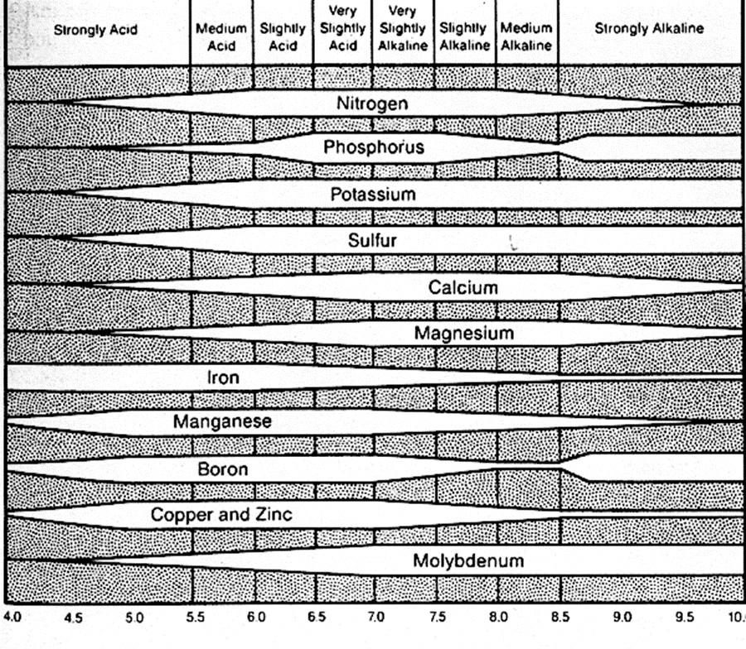
Figure 1: Nutrient Availability at pH

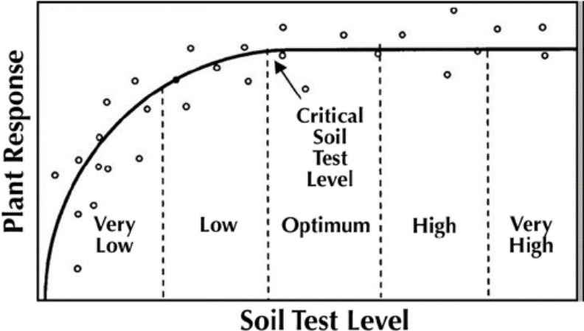

Figure 2: Plant Response Chart

Very low: A plant response is most likely if the indicated nutrient is applied. A large portion of the nutrient requirement must come from fertilization.

Low: A plant response is likely if the indicated nutrient is applied. A portion of the nutrient requirement must come from fertilization.

Medium: A plant response may or may not occur if the indicated nutrient is applied. A small portion of the nutrient requirement must come from fertilization.

High: Plant response is not expected. No additional fertilizer is needed.

Very high: Plant response is not expected. The soil can supply much more than the turf requires. Additional fertilizer should not be added to avoid nutritional problems and adverse environmental consequences.

Standards and Criteria

Section VI. Turfgrass Nutrient Recommendations for Home Lawns, Office Parks, Public Lands and Other Similar Residential/Commercial Grounds
Definitions

For the purposes of this section, the following definitions, as presented by the Association of American Plant Food Control Officials (AAPFCO), apply:

"Enhanced efficiency fertilizer" describes fertilizer products with characteristics that allow increased plant nutrient availability and reduce the potential of nutrient losses to the environment when compared to an appropriate reference product.

"Slow or controlled release fertilizer" means a fertilizer containing a plant nutrient in a form which delays its availability for plant uptake and use after application, or which extends its availability to the plant significantly longer than a reference "rapidly available nutrient fertilizer" such as ammonium nitrate, urea, ammonium phosphate or potassium chloride. A slow or controlled release fertilizer must contain a minimum of 15 percent slowly available forms of nitrogen.

"Water soluble nitrogen", "WSN", or "readily available nitrogen" means: Water soluble nitrogen in either ammonical, urea, or nitrate form that does not have a controlled release, or slow response.

Recommended Season of Application For Nitrogen Fertilizers - Applies to all Turf

A nitrogen fertilization schedule weighted toward fall application is recommended and preferred for agronomic quality and persistence of cool season turfgrass; however, the acceptable window of applications is much wider than this for nutrient management. The nutrient management recommended application season for nitrogen fertilizers to cool season turfgrasses begins six weeks prior to the last spring average killing frost date and ends six weeks past the first fall average killing frost date (see Figures 6-1 & 6-2). Applications of nitrogen during the intervening late fall and winter period should be avoided due to higher potential leaching or runoff risk, but where necessary, apply no more than 0.5 pounds per 1,000 ft2 of water soluble nitrogen within a 30-day period. Higher application rates may be used during this late fall and winter period by using materials containing slowly available sources of nitrogen, if the water soluble nitrogen contained in the fertilizer does not exceed the recommended maximum of 0.5 pounds per 1,000
ft2 rate. Do not apply nitrogen or phosphorus fertilizers when the ground is frozen.
The acceptable nitrogen fertilizer application season for non-overseeded warm season turfgrass begins no earlier than the last spring average killing frost date and ends no later than one month prior to the first fall average killing frost date (see Figures 6-1 & 6-2).

96

Figure 6-1

VIRGINIA
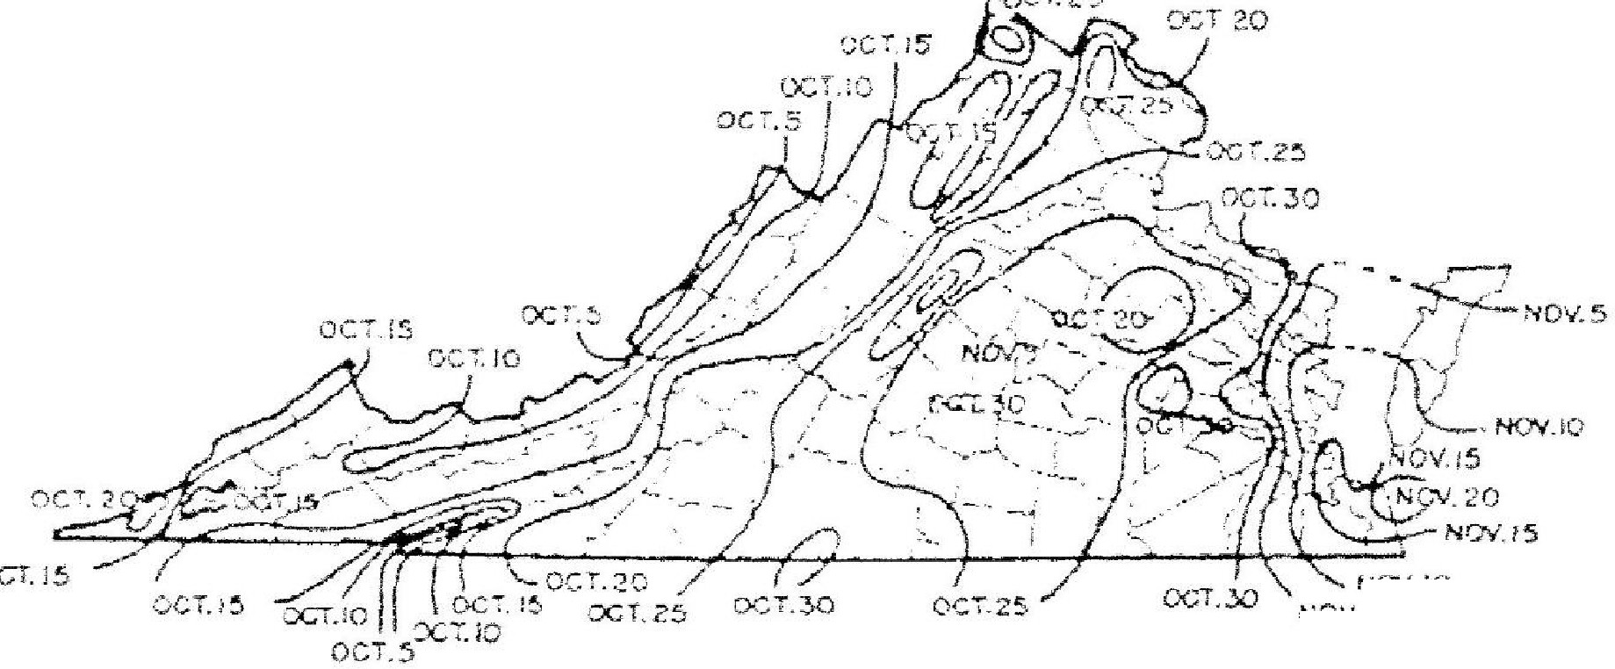AY•F",'A C,E DATES OF
><LUNG FR"".,.
•• ;:, j
IN F,iLL
f'lRST
NOl/.(0
NOV.

Figure s-2

VIRGINIA
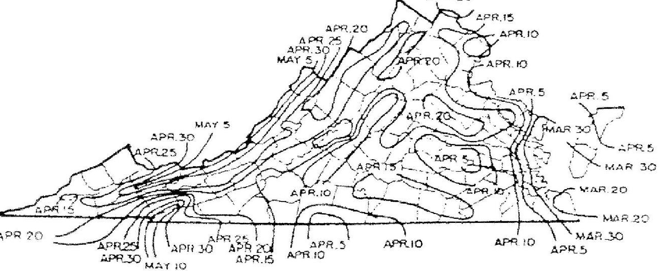.
Kll.llNG
AVE'RAGE DATn-
FROS"T >N ...:.PRI.:N>(,".
_., OLFA ..-

97

Per Application Rates

Do not apply more than 0.7 pounds of water soluble nitrogen per 1,000 ft² within a 30-day period. For cool season grasses, do not apply more than 0.9 pounds of total nitrogen per 1,000 ft² within a 30-day period. For warm season grasses, do not apply more than 1.0 pounds of total nitrogen per 1,000 ft² within a 30-day period. Lower per application rates of water soluble nitrogen sources or use of slowly available nitrogen sources should be ut ilized on very permeable sandy soils, shallow soils over fractured bedrock, or areas near water wells.

Annual Application Rates for Home Lawns and Commercial Turf

Up to 3.5 pounds per 1,000 ft2 of nitrogen may be applied annually to cool season grass species or up to 4 pounds per 1,000 ft2 may be applied annually to warm season grass species using
100 percent water soluble nitrogen sources. Lower rates of nitrogen application may be desirable on those mature stands of grasses that require less nitrogen for long-term quality. As a result, lower application rates will probably be more suited to the fine leaf fescues (hard fescue, chewings fescue, creeping red fescue, and sheep fescue) and non-overseeded zoysiagrass. Lower rates should also be used on less intensively managed areas.
Use of Slowly Available Forms of Nitrogen

For slow or controlled release fertilizer sources, or enhanced efficiency fertilizer sources, no more than 0.9 pounds of nitrogen per 1,000 ft² may; be applied to cool season grasses within a 30-day period and no more than 1.0 pounds of nitrogen per 1,000 ft² may be applied to warm season grasses within a 30-day period.

Provided the fertilizer label guarantees that the product can be used in such a way that it will not release more than 0.7 pounds of nitrogen per 1,000 ft2 in a 30-day period, no more than 2.5 pounds of nitrogen per 1,000 ft2 may be applied in a single application. Additionally, total
annual applications shall not exceed 80 percent of the annual nitrogen rates for cool or warm season grasses.

Phosphorus and Potassium Nutrient Needs (Established Turf)

Apply phosphorus (P20s) and potassium (K20) fertilizers as indicated necessary by a soil test using the following guidelines:

Soil Test Level

L M H VH
Nutrient Needs tr,ounds per
1,000 ft )*
P205 K20
2-3 2-3
1-2 1-2
0.5-1 0.5-1
0 0

* For the lower soil test level within a rating, use the higher side of the range and for higher soil test level within a rating use the lower side of the recommendation range. (For example the recommendation for a P2O₅ soil test level of L- would be 3 pounds per 1,000 ft2.)
Do not use high phosphorus ratio fertilizers such as 10-10-10 or 5-10-10, unless soil tests indicate phosphorus availability below the M+ level.

98

Recommendations for Establishment of Turf

These recommendations are for timely planted turfgrass, that is, the seed or vegetative material (sod, plugs, and /or sprigs), are planted at a time of the year when temperatures and moisture are adequate to maximize turfgrass establishment. These recommended establishment periods would be late summer to early fall for cool-season turfgrasses and late spring through mid­ summer for warm-season turfgrasses.

Nitrogen Applications

At the time of establishment, apply no more than 0.9 pounds per 1,000 ft² of total nitrogen for cool season grasses or 1.0 pounds per 1,000 ft² of total nitrogen for warm season grasses, using a material containing slowly available forms of nitrogen, followed by one or two applications beginning 30 days after planting, not to exceed a total of 1.8 pounds per 1,000 ft²
total for cool season grasses and 2.0 pounds per 1,000 ft² for warm season grasses for the establishment period. Applications of WSN cannot exceed more than 0.7 pounds per 1,000 ft2 within a 30-day period.

Phosphorus and Potassium Recommendations for Establishment

Soil Test Level
Nutrient Needs (pounds per
1,000 ff') *
P20 K20

L | 3-4 | 2-3
M | 2-3 | 1-2
H | 2-1 | 0.5-1
VH | 0 | 0
* For the lower soil test level within a rating, use the higher side of the range and for higher soil test level within a rating use the lower side of the recommendation range.

99

Nutrient Recommendations for Golf Courses
Nitrogen Timing

The beginning and ending dates for application of nitrogen shall be determined using guidance and frost date maps contained in the Season of Application for Nitrogen section, Figures 6-1 and 6-2.

If the full rate or the highest rate of the recommendation range for a monthly application is applied in a single application, then the interval of application for nitrogen shall be at least 30 days to allow turf to utilize previous nitrogen applications. If several applications are to be made for the monthly nitrogen rate, then the timing of the applications shall be at approximately even intervals, with the rate per application to be evenly divided between each application with the total nitrogen applied not to exceed the maximum monthly rate. Use of Water Insoluble Nitrogen forms of Nitrogen is encouraged.

Nitrogen Rates

 | Grass Type | Maximum WSN Rate Per Application - pounds per 1,000  ft2 | Total Annual Nitrogen Rate  - pounds per  1,000 ft2a
Greens |  | 0.7 \OJ | 3-6
Tees |  | 0.7 (tl) | 2-5
Fairways | Cool Season | 0.7 \CJ | 2-3
 | Warm Season | 0.7 \CJ | 3-4
Fairways -  Intensive Management | Cool Season | 0.5 \OJ | 3-4
 | Warm Season | 0.5 \OJ | 3.5-4.5
Overseeding Warm Season Fairways |  | .5 | 1.25
Roughs |  | 0.7 ,eJ | 1-3

Fairways-Overseeding Warm Season Fairways
- For warm season grasses, up to 0.7 pounds of nitrogen per 1,000 tt2 in a 30-day period may be applied in the Fall after perennial ryegrass overseeding is well established. An additional nitrogen application of 0.7 pounds per 1,000 ft² may be made in February-March to overseeded perennial ryegrass if growth and color indicate need. Applications using WSN may not exceed 0.7 pounds per 1,000 ft2 within a 30-day period.
  - Soluble nitrogen rates of 0.25 pounds per 1,000 ft2_or less which may be a component of a pesticide or minor element application, may be applied any time during the application windows described in Recommended Season of Application for Nitrogen Fertilizers of this section, but must be considered with the total annual nitrogen application rate.

    - Use higher rates for intensively used turf where accelerated growth and/or rapid recovery are required, use lower rates for maintenance of lesser used areas; do not exceed total annual nitrogen levels as stated above.

100

    - Greens and Tees - Per application timing must be a minimum of 30 days between applications. A rate of 0.9 pounds per 1,000 ft2 of total nitrogen may be applied for cool season grasses or 1.0 pounds per 1,000 ft² of total nitrogen may be applied for warm
season grasses using a material containing slowly available forms of nitrogen.

    - Fairways-Normal Management (Non-Irrigated or Irrigated) - Per Application timing must be a minimum of 30 days between applications. Total nitrogen application rates of 0.9 pounds per 1,000 ft² of total nitrogen may be applied for cool season grasses or 1.0 pound per 1,000 ft² of total nitrogen may be applied for warm season grasses using a material containing slowly available forms of nitrogen.

    - Fairways-Intensive Management (Irrigated)- Per Application timing must be a minimum of 15 days between applications. This option requires optimized timing of more frequent applications of nitrogen with lesser rates per application. Alternatively, a maximum application rate of 0.9 pounds per 1,000 ft² of total nitrogen for cool season grasses or
1.0 pounds per 1,000 ft² of total nitrogen for warm season grasses using a material containing slowly available forms of nitrogen may be applied with a minimum of 30 days between applications.

    - Foliar fertilizer may be applied to warm season grasses within 30 da s prior to the first killing frost in the fall, at a rate not to exceed 0.1 pounds per 1,000 ft of nitrogen per application. This application must be accounted for in the total annual nitrogen rate.

Phosphorus and Potassium Recommendations for Established Golf Courses

Apply phosphorus (P₂0₅) and potassium (K₂0) fertilizers as indicated by a soil test using the following guidelines:

Soil Test Level
Nutrient Needs (pounds per 1,000 ft²)*
P20s K20

L | 2-3 | 2-3
M | 1-2 | 1-2
H | 0.5-1 | 0.5-1
VH | 0 | 0
* For the lower soil test level within a rating, use the higher side of the range and for higher soil test level within a rating use the lower side of the recommendation range.
  - For irrigated turf grown on Natural!¥ Occurring and Modified Sand Based soils only, up to
Q.5 pounds of P₂0₅ per 1,000 ft may be appl ied, if needed, to aid in recovery of
damaged turf during times of extreme use. No phosphorus applications shall be made when the soil phosphorus test level is above 65% saturation, based on the soil test phosphorus values and region as listed in Table 4-1 of Section IV.

- Avoid the general use of high phosphorus ratio fertilizers such as 10-10-10 or 5-10-10, unless soil tests indicate phosphorus availability below the M+ level.

Nitrogen Management on Athletic Fields - Cool Season Grasses

  - This program is intended for those fields which are under heavy use.

  - Nitrogen recommendations are based on the assumption that there is adequate soil moisture to promote good turf growth at the time of application. If no r ainfall has occurred since the last application, further applications should be delayed until significant soil moisture is available.

101

Cool Season Grasses | Maintenance Programa  Normal Intensive
When to Applyb | Pounds !)er  1,000 ft²  Nitrooen
After August 15 | --- | 0.5
September | 0.7 | 0.7c
October | 0.7c | 0.7c
November | 0.5 | 0.7c
April 15 - May 15 | 0.5 | 0.5
June 1 - June 15 | -- | 0.5

Notes:

  - Soluble nitrogen rates of 0.25 pounds per 1,000 ft2 or less which may be a component of a pesticide or minor element application may be applied any time the turi is actively growing, but must be considered with the total annual nitrogen application rate.
  - WSN = water soluble nitrogen; WIN = water insoluble nitrogen
    - Intensive managed areas must be irrigated.

    - The beginning and ending dates for application of nitrogen shall be determined using guidance and frost date maps contained in the preceding Season of Application for Nitrogen section, using Figures 6-1 and 6-2.

    - Rates up to 0.9 pounds per 1,000 ft² of total nitrogen can be applied using am aterial containing slowly available forms of nitrogen, with a minimum of 30 days between applications.
    - Make this application only if turi use warrants additional nitrogen for sustaining desirable growth and /or color.

Nitrogen Management on Athletic Fields - Wann Season Grasses

The following comments apply to both Naturally Occurring or Modified Sand based Fields and Predominantly Sitt/Clay Soil Fields:

      - Annual nitrogen rates for warm season grasses shall not exceed 4 pounds in areas which have the average first killing frost on or before October 20, and shall not exceed 5 pounds in areas which have the average first killing frost after October 20 as shown in Figure 6-1. Nitrogen rates and timings for overseeding warm season grasses are not included in these rates.

      - April 15 - May 15 applications should not be made until after complete green-up of turf.
      - Nitrogen applications June through August should be coordinated with anticipated rainfall if irrigation is not available.

- Use the lower end of the ranges for non-irrigated fields and the higher end of the ranges
should be used on fields with irrigation.

102

Nitrogen rates towards the higher end of the ranges may be applied on heavily used fields to accelerate recovery, however per application and annual rates cannot be exceeded.

Bermudagrass - Predominantlv Silt/Clav Soil Fieldsa
When to Applyb | Pounds JJer 1,000 ft²  Nitroaen" | First Fall Killing  Frost Dateb
Aoril 15 - Mav 15 | 0.5-0.7(") | Before Oct. 20
June | 0.7
July | 0.5 - 0.7 \U/
August | 0.5 - 0.7 lO)
Sept 1 - Sept 15 | 0.5 -0.7 lC) | After Oct. 20
If overseeded with perennial ryeqrass
Oct- Nov | 0.5 1e1
Feb-Mar | 0.5 \e)

Bermudagrass - Naturally Occurring or Modified Sand based Fieldsa
When to Applyb | Pounds per  1,000 ft2  Nitrogen | First Fall Killing Frost Dateb
April 15 - May 15 | 0.5 -0.TCJ | Before Oct. 20
June1 | Q_7lC/
July | 0.7\C)
AuQust | Q.7lC))
Sept 1 - Sept 15 | Q_7c | After Oct. 20
If overseeded with perennial rveQrass
Oct - Nov | 0.5 \eJ
Feb - Mar | 0.5 \e)

The following notes apply to both of the Bermudagrass tables above:

- In the Piedmont and the Ridge and Valley areas of Virginia, the existing native soil will normally be comprised predominantly of clay and/or silt and these soils have inherently lower water infiltration and percolation rates and greater nutrient holding capacity. However, most areas of the Coastal Plain have existing native soils that are predominantly sandy textured soils and other facllities throughout the state may choose to install modified soil root zones that are predominantly sand (>50%) in order to maximize drainage and reduce compaction tendency. If subsurface drain tile surrounded by sand and/or gravel has been installed under the playing surface of any of these fields, their nitrogen programs should be managed as predominantly sand-based systems to minimize nutrient leaching.

- The beginning and ending dates for application of nitrogen shall be determined using guidance and frost date maps contained in the Season of Application for Nitrogen section, Figures 6-1 and 6-2.
- WSN must be applied as two applications not to exceed 0.35 pounds per 1,000 ft2 each with a minimum of 15 days between applications. Alternatively, using a material that contains slowly available nitrogen sources, split applications of 0.5 pounds per 1,000 ft² may be applied with a minimum of 15 days between applications.

103

- If a material containing slowly available forms of nitrogen is used, rates up to 1.0 pounds of nitrogen per 1,000 ft.2 may be applied in a single application with a minimum of 30 days between applications.

- For overseeded warm season grasses, an additional 0.7 pounds per 1,000ft2 ofWSN may be applied in the Fall after the perennial ryegrass overseeding is well established. The WSN must be applied as two applications not to exceed 0.35 pounds per 1,000 ft² of nitrogen each, with a minimum of 15 days between applications. Additional WSN application of 0.5 pounds per 1,000 ft2 may be made in February-March to overseeded perennial ryegrass if growth and color indicate need. Alternatively, split applications of
0.5 pounds of nitrogen per 1,000 ft2 each with a minimum of 15 days between applications may be applied using a material containing slowly available nitrogen sources.

Phosphorus and Potassium Recommendations Athletic Fields
Apply phosphorus (P₂0₅) and potassium (K₂0) fertilizers as indicated by a soil test using the following guidelines:

Soil Test Level
Nutrient Needs (r,ounds per
1,000 ft)*
P20s K20
L | 2-3 | 2-3
M | 1-2 | 1-2
H | 0.5-1 | 0.5-1
VH | 0 | 0

* For the lower soil test level within a rating, use the higher side of the range and for higher soil test level within a rating use the lower side of the recommendation range.
- For irrigated turf grown on Natural!¥ Occurring and Modified Sand Based soils only, up to
0.5 pounds of P20s per 1,000 ft may be applied, if needed, to aid in recovery of damaged turf during times of extreme use. No phosphorus applications shall be made when the soil phosphorus test level is above 65% saturation, based on the soil test phosphorus values and region as listed in Table 4-1 of Section IV.
- Avoid the general use of high phosphorus ratio fertilizers such as 10-10-10 or 5-10-10, unless soil tests indicate phosphorus availability below the M+ level.

104

Establishment/Grow-In Recommendations for Golf Courses, Athletic Fields, and Sod Production
(These rates replace normal maintenance fertilizer applications that would have occurred during these time periods.)
Warm Season Grasses: Predominantly Silt/Clay Soils
+ Plant Date - late May -June for sprigs, plugs, sod, or seeding.
- Apply P20s and K20 as needed based on soil test recommendations, incorporate into the top 2 inches if possible.
- At Planting - Up to 1.0 pounds of nitrogen per 1,000 ft² using a material containing slowly available forms of nitrogen may be applied as one application or lesser amounts applied at regular intervals, through the first 4 weeks, not to exceed a total of 1.0 pounds of nitrogen per 1,000ft2.
- Four weeks after planting - 0.25 pounds.of WSN per 1,000 ft² per week for the next 4
weeks.
Naturally Occurring or Modified Sand Based Soils
- Plant Date - late May -June for sprigs, plugs, sod, or seeding.
- Apply P₂0₅ and K₂0 as needed based on soil test recommendations, incorporate into the top 2 inches if possible.
- At Planting - Up to 1.0 pounds of nitrogen per 1,000 ft² using a material containing slowly available forms of nitrogen may be applied as one application or lesser amounts at regular intervals through the first 4 weeks, not to exceed a total of 1.0 pounds of nitrogen per 1,000 ft2.
- Four weeks after planting - 0.25 pounds per1,000 ft² using a material containing slowly available forms of nitrogen per week for the next 4 weeks.

Cool Season Grasses:

Predominantly Silt/Clay Soils
+ Plant Date - August - September (preferred)
- Apply P₂0₅ and K₂0 as needed based on soil test recommendations, incorporate into the top 2 inches if possible.
+ At Planting - up to 0.9 pounds of nitrogen per 1,000 ft² using a material containing slowly available forms of nitrogen ma1' be applied; 30 days after planting, apply up to 0.5 pounds of nitrogen per 1,000 ft² every week for the next 4 weeks.
Naturally Occurring or Modified Sand Based Soils
- Plant Date - August -September (preferred)
- Apply P₂0₅ and K₂0 as needed based on soil test recommendations, incorporate into the top 2 inches if possible.
- At Planting - up to 0.9 pounds of nitrogen per 1,000 ft2 using a material containing slowly
available forms of nitrogen may be applied.
- Apply up to 0.25 pounds of nitrogen per 1,000 ft² per week after germination is complete, for the next 8 weeks. If using a material that contains slowly available forms of nitrogen, up to 0.5 pounds of nitrogen per 1,000 ft² every two weeks may be applied after germination is complete for the next 8 weeks.

105

Sod Installations:

Site preparation should include a soil test, which can be done several months before the project begins in order to have time to get test results back. Phosphorus, potassium and lime applications should be based on soil test analysis to increase the likelihood of a successful installation. Shallow incorporation of material into the top 2 inches of the soil is preferred prior to sod installation, especially if lime is required.

No more than 0.7 pounds of nitrogen per 1,000 ft² of WSN may be applied before sod is installed. Alternatively, using a material with slowly available forms of nitrogen, 0.9 rounds of nitrogen per 1,000 ft² for cool season grasses or 1.0 pounds of nitrogen per 1,000 ft for warm season grasses may be applied before sod is installed.

After installation apply adequate amounts of water to maintain sufficient soil moisture (i.e. to prevent visible wilt symptoms). Excessive water will limit initial root development. After roots begin to establish (as verified by lightly tugging on the sod pieces), shift irrigation strategy to a deep and infrequent program in order to encourage deep root growth. Apply approximately 1 inch of water per week (either by rainfall or irrigation), making sure that the water is being accepted by the soil profile without running off. This will insure thorough wetting of the soil profile.

After sod has completed rooting and is well established, initiate the normal nitrogen management program as described for the appropriate use shall be recommended.

Phosphorus and Potassium Recommendations for Establishment/Grow-In/Installation

Soil Test Level Nutrient Needs {founds per
1,000 ft l *
P₂0₅ K₂0
L | 3-4 | 2-3
M | 2-3 | 1-2
H | 2-1 | 0.5-1
VH | O | 0
* For the lower soil test level within a rating, use the higher side of the range and for higher soil test level within a rating use the lower side of the recommendation range.

106

Other Turf Management Considerations for Golf Courses, Athletic fields, and Home Lawns

Lime Recommendations

Lime should be recommended based on a soil test to maintain soil pH within an agronomic range for turfgrass.

For new seedings where lime is recommended, incorporate the lime into the topsoil for best results.

Returning Grass Clippings

Recycling of clippings on turf should be encouraged as an effective means of recycling nitrogen, phosphorus, and potassium. Proper mowing practices that ensure no more than 1/3 of the leaf blade is removed in any cutting event will enhance turf appearance and performance when clippings are returned. Return all leaf clippings from mowing events to the turf rather than discharging them onto sidewalks or streets. Rotary mulching mowers can further enhance clipping recycling by reducing the size of clippings being returned to the turfgrass canopy.

Management of Collected Clippings

If clippings are collected they should be disposed of properly. They may be composted or spread uniformly as a thin layer over other turf areas or areas where the nutrient content of the clippings can be recycled through actively growing plants. They should not be blown onto impervious surfaces or surface waters, dumped down stormwater drains, or piled outside where rainwater will leach out the nutrients creating the potential for nutrient loss to the environment.

Use of Iron

Iron applications (particularly foliar applications) may periodically be used for enhanced greening as an alternative to nitrogen. These applications are most beneficial if applied in late spring through summer for cool season grasses and in late summer/fall applications for warm­ season grasses.

Impervious Surfaces

Do not apply fertilizers containing nitrogen or phosphorus to impervious surfaces (sidewalks, streets, etc.). Remove any granular materials that land on impervious surfaces by sweeping and collecting, and either put the collected material back in the bag, or spread it onto the turf and /or using a leaf blower etc. to return the fertilizer back to the turfgrass canopy.

107

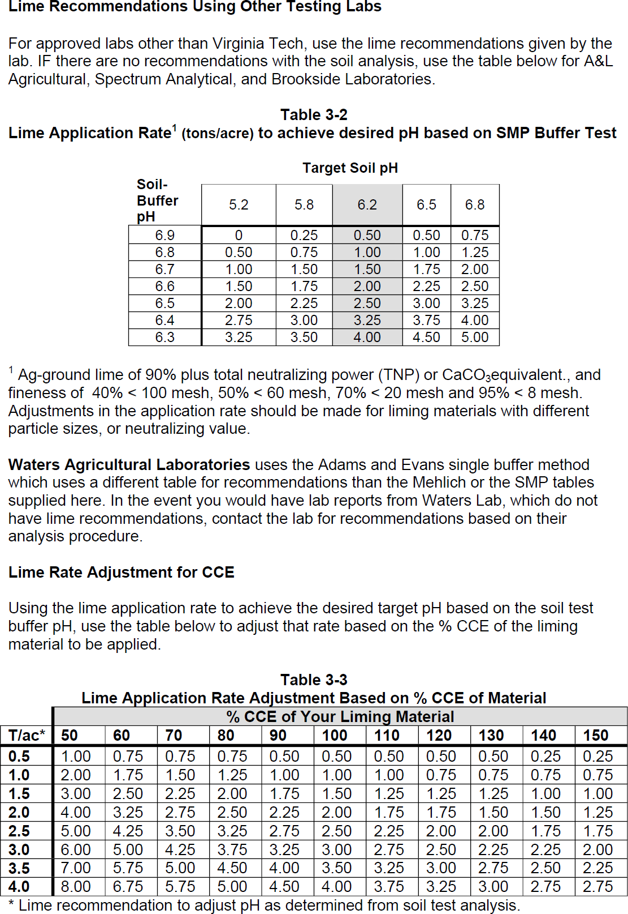

Figure 3: CEC Chart

Fertilizer Labels
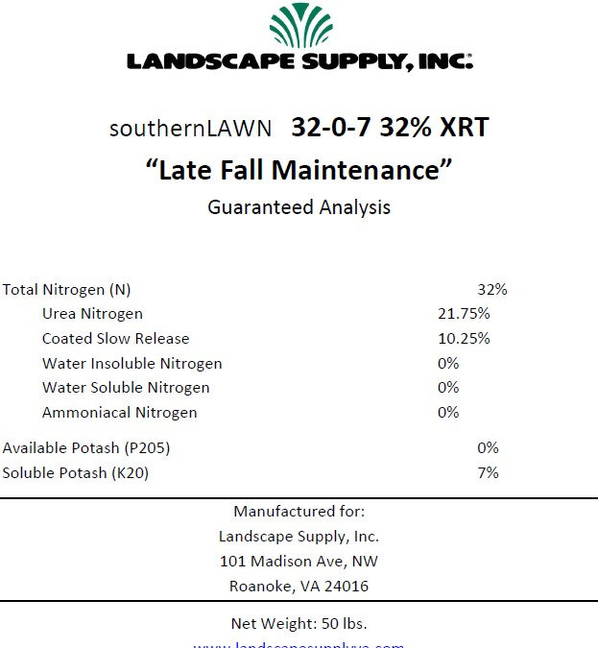

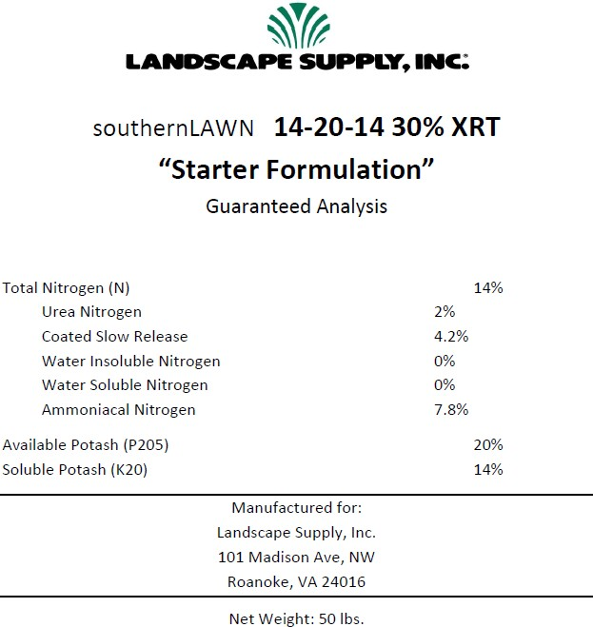

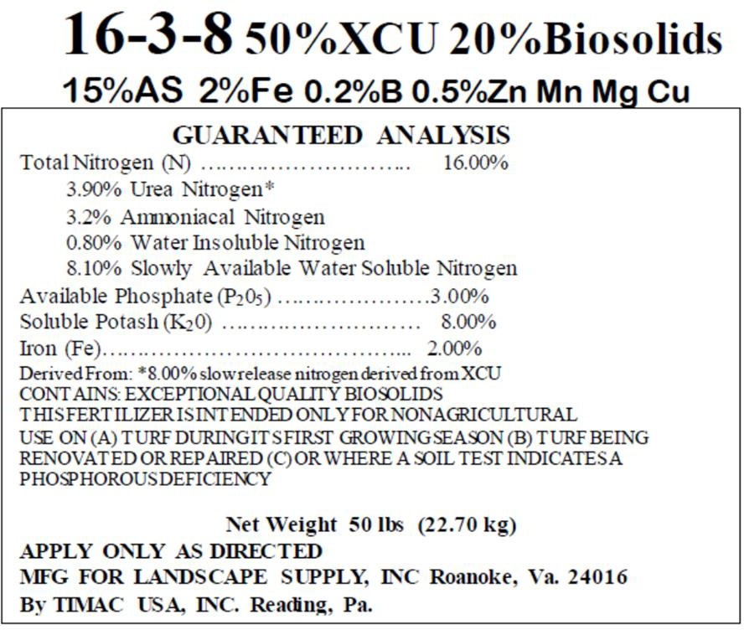

Soil Test Results
See attached files.

